Standardization of the Swordfish *Xiphias gladius* Catch per Unit Effort Data Caught by the Hawaii-based Longline Fishery from 1994-2016 Using Generalized Linear Models[1]

Sculley, Michellea Yau, AnniebKapur, Maiaa

a Joint Institute for Marine and Atmospheric Research, University of Hawaii  
c/o National Marine Fisheries Service  
1845 Wasp Boulevard  
Honolulu, HI 96818

b Pacific Islands Fisheries Science Center  
National Marine Fisheries Service  
1845 Wasp Boulevard  
Honolulu, HI 96818

# Abstract

The swordfish (Xiphias gladius) catch per unit effort for the Hawaii-based longline fishery was standardized from the Pacific Islands Regional Observer data set. The fishery was divided into the tuna-targeting deep-set sector and the swordfish-targeting shallow-set sector. Additionally, the shallow-set sector was standardized in two time periods: an early period (1995–2000) and a late period (2005–2016) because the shallow-set fishery was closed from 2001 to 2004, and regulations caused changes in the fleet operations thereafter. Four different models were evaluated to standardize the CPUE for each time series: the delta-lognormal model, the negative binomial model, the zero-inflated negative binomial model, and the Poisson model. The delta-lognormal model provided the best model fits and explained the most percent deviance of those evaluated. The models explained between 26 and 65% of the deviance in the shallow-set sector and 35% of the deviance in the positive catches for the deep-set sector, but only 4% of the proportion of positive catches in the deep-set sector. The shallow-set standardized annual CPUE values show an increase in catch rates in the early period followed by a peak in 2006 after the closure. CPUE values increased again from 2010 to the present. The CPUE values for the deep-set sector were relatively flat and had high variability.

# Introduction

Broadbill swordfish (*Xiphias gladius*) inhabit the Pacific Ocean between 50° N and 50° S. They are a commercially important highly migratory species caught primarily by the Japanese, Taiwanese, and U.S. longline fisheries (Bigelow *et al.*, 1999). The swordfish stock in the North Pacific has been assessed as a single stock scenario and under a two stock scenario, with one stock in the western central Pacific Ocean and one stock in the eastern Pacific Ocean. These stocks were assessed in 2009 and again in 2014 by the Billfish Working Group (BILLWG) of the International Scientific Committee for Tuna and Tuna-like Species in the North Pacific Ocean (ISC) (ISC BILLWG, 2009; ISC BILLWG, 2014). The Eastern Pacific Stock of a different spatial delineation was also assessed by the Inter-American Tropical Tuna Commission (IATTC) in 2010 (IATTC SAP, 2011).

The BILLWG of the International Scientific Committee for Tuna and Tuna-like Species in the North Pacific (ISC) has proposed to attempt a benchmark assessment of North Pacific swordfish Xiphias gladius in 2018. In preparation for the assessment, this working paper describes the standardization swordfish catch rates from the Hawaii-based longline fleet, which targets swordfish in the shallow-set sector and catches swordfish as bycatch in the deep-set sector. Swordfish are caught as targeted-species in the Hawaiian longline shallow-set fishery sector (< 15 hooks per float) and as bycatch in the tuna targeting Hawaiian longline deep-set fishery sector (≥ 15 hooks per float). This fleet has been described previously by Ito and Childers (2014) and also in a working paper submitted to the same BILLWG session (Ito and Childers 2018) and there have not been additional substantial changes to the fishery since 2014. Historically the Hawaiian longline fishery has targeted tuna; however, in the early 1990s the number of vessels targeting swordfish began increasing and the fleet accounted for 40% of the total US swordfish catch in 2012. Observers were first placed onboard longline vessels in 1994. Interactions with protected sea turtles caused the closure of the shallow-set swordfish fishery from February 2001 to May 2004 (Gilman *et al.,* 2007). During this time many vessels targeting swordfish began targeting tuna. A second closure occurred March–December 2006 when the Hawaii-based shallow-set longline fishery for swordfish reached the annual limit for interactions with loggerhead sea turtles (NMFS, 2017). Several changes to the reporting regulations have occurred since its onset in 1994 (Pacific Islands Region Office, 2017). Observer coverage varied significantly prior to 2000, with observer coverage between 3.3 and 10.4 % for the entire fishery (NMFS, 2017). Starting in 2001, the observer program had a target of 20% observer coverage on deep-set longline vessels and mandatory 100% observer coverage on shallow-set longline vessels.

# Methods

## Data Sources

The Pacific Islands Regional Fishery Observer Program (PIROP) provides detailed set-by-set data on the Hawaii-based longline fishery including catch in numbers of fish and a variety of operational variables, among them: location as latitude and longitude, vessel ID, hooks per float, total number of hooks set, type of bait used, and time longlines were set, following the procedures outline in the PIROP observer manual (Pacific Islands Regional Office, 2017). The standardization uses this data set instead of the commercial logbook data to ensure the analyses were conducted according to ISC standards on using the best available science. Data were extracted from the PIROP database on 10 October 2017 for this analysis.

The environmental variables used in the standardization were obtained from publically available data sets. Sea Surface temperatures (SST) from January 1994 to October 2012 were monthly 0.1° resolution composites from the AVHRR Pathfinder v4.1 satellite. SST from November 2012 to present were based on monthly 0.5° resolution composites from the NOAA GOES-E/W satellite. Both SST time series were downloaded from Pacific Islands Fisheries Science Center (PIFSC) OceanWatch (2017). Both the Southern Oscillation Index (SOI) and the Pacific Decadal Oscillation Index (PDO) were monthly region wide indices (NOAA NCDC, 2017). Lunar illumination data consisted of values between 0 and 1 which measured the proportion of the moon illuminated above Hawaii. It can be used as a proxy to indicate lunar stage with 0 indicating a new moon and 1 indicating a full moon (US Naval Observatory, 2017). Mixed layer depth (MLD) were based on 0.33° × 1° monthly means of GODAS data provided by the NOAA/OAR/ESRL PSD, Boulder, Colorado, USA[2].

## CPUE Standardization

Swordfish CPUE were divided into three time series before standardization to account for significant differences in the shallow- and deep-set fisheries and regulation changes. Deep-set data were standardized as a single time series from 1994 to 2016 and shallow-set data were standardized from 1994 to 2000 and 2004 to 2016 to account for the fishery closure and changes in regulations which changed the fishing practices of the fleet.

Swordfish CPUE standardizations were attempted using four different generalized linear Mixed models (GLMMs): delta-lognormal, Poisson, negative binomial, and zero-inflated negative binomial. Model selection was based upon goodness of fit using AIC or percent deviance explained. The negative binomial was preferred over the zero-inflated negative binomial model based upon a Chi-squared likelihood ratio test. The Poisson and negative binomial models explained very little of the percent deviance explained (less than 5%) and had poor model fits to the data and so the delta-lognormal model was chosen to standardize the data (Table 1).

Standardization with a delta-lognormal model is made up of two steps: first, fitting of the entire data set with a binomial model to estimate the probability of a positive catch, second, fitting the positive catches only with a lognormal model. The late shallow time series did not include the binomial component as more than 99% of the sets caught at least one swordfish and the probability of having a positive catch would be very close to one for each year. The response variable for the binomial model was a 0/1 indicating if a swordfish was caught in a set and for the lognormal model was the number of fish caught per 1000 hooks. Fifteen explanatory variables were explored for each model: Year, Quarter, Bait Type, and Hooks Per Float (HPF) were included as factors; SST, MLD, number of Hooks Per Set (HPSet), Lunar Illumination (Illum), PDO, SOI, Latitude, and Longitude were included as continuous variables; and permit number, a proxy for vessel, was included as a random effect. The time the set began, indicating when the lines were first put into the water, was tested as two different variables: as a continuous variable using the actual time recorded (BeginSetTime) and as a factor with four levels indicating the time of day divided at midnight, 0600, noon, and 1800 (Begin).

Explanatory variables were added using forward stepwise selection with variables being selected based upon the lowest AIC, most deviance explained, and if they were statistically significant based upon a Chi-squared likelihood ratio test. Additional variables were not included if they were not significant based upon the likelihood test or if they increased the percent deviance explained by less than 0.25% (Bigelow *et al.*, 1999; Maunder and Punt 2004). Final models for each time series are in Table 2.

Annual mean CPUE was calculated from the final binomial and lognormal models using the estimated marginal means package in R (emmeans, Lenth *et al*., 2017; R version 3.4.0, R Core Team, 2017) which accounts for the unbalanced nature of the data and missing values, not allowing for large numbers of observations in a level of a factor to have an undue influence on the average of the values. Annual mean CPUE was then back-transformed into normal space and bias corrected. Then the means from the binomial model were multiplied with the means from the lognormal model to obtain the final standardized annual CPUE values. Standard deviations were estimated in a similar manner: individual model values were back transformed into normal space then combined for each time series based upon the Goodman (1960) estimator (Lauretta *et al.*, 2016).

# Results

## Descriptive Catch Statistics

The spatial distribution of CPUE for the Hawaii-based longline shallow-set fishery indicate that the largest CPUE values were in the north and western portions of the primary fishing area (Figure 1) as seen by the two CPUE contours running approximately from the northeast corner of the region to the south west corner. This trend was also evident in the annual CPUE spatial distributions (Figure 2) prior to the 2001–2004 closure when shallow-sets occurred primarily north of the Hawaiian Islands. After 2001–2004, shallow-sets occurred more frequently south of the Hawaiian Islands. The total number of hooks per set was highest around and north of the Hawaiian Islands (Figure 3) which coincides with the locations of the highest number of total sets in the North Pacific subtropical convergence zone (Figure 4).

The majority of the sets in the shallow-set sector has between 4 and 6 hooks per float and was set between 1500 and 0600 (Figure 5). For sets with higher HPF, most of the sets begin around dawn. When some of the operational variables were explored on an annual basis, the substantial changes in the shallow-set sector before and after the closure were evident. For example, prior to the closure in 2001 sets were began between dusk and dawn (Figure 6) however, after the fishery reopened in 2005 almost all of the sets begin between dusk and midnight, suggesting a specific targeting of swordfish catches. Similarly, prior to the closure there were a notable number of sets with hooks per float over 10 but after the fishery almost all the sets have 4 to 6 hooks per float (Figure 7).

Figures 8 through 10 show the nominal CPUE versus each explanatory variable explored in the standardization. Overall, CPUE values were higher and less variable after the closure (Figure 8). CPUE values were lowest in quarter 3 and highest in quarter 1. The highest CPUE values were caught when the number of hooks per float was between 4 and 6 which suggests that the fishery targets swordfish more specifically after the closure given the prevalence of the use of 4 to 6 hpf after the closure. As seen in Figure 1, CPUE values were low in the south, begin increasing north of 20°N latitude, were fairly constant between 30°N and 40°N, after which they decline (Figure 9). There was little change in CPUE with longitude except for a slight dip around the Hawaiian Islands. CPUE decreases with increasing number of hooks per set, and increases with increased lunar illumination from a mean of approximately eight swordfish per 1000 hooks during the new moon to a mean of approximately 13 swordfish per 1000 hooks during the full moon. For mixed layer depth, sea surface temperature, PDO and SOI, it was difficult to identify significant trends (Figure 10) although there did appear to be lower CPUE values at deeper MLD and higher CPUE values at intermediate temperatures (around 24°C).

CPUE values for the deep-set fishery were an order of magnitude lower than the shallow-set CPUE values, with mean CPUE values between 0 and 1.2 fish per 1000 hooks (Figure 11). The annual spatial distribution of mean CPUE was low and relatively stable throughout the time period and the region (Figure 12), although there appears to be an expansion of effort over time. Effort was highest around the Hawaiian Islands, both north and south of the main eight islands for number of hooks set (Figure 13) and number of sets recorded (Figure 14).

The operational data show a very different fishery than the shallow-set sector, where the time when sets were begun was primarily during daylight hours and few sets were started after dusk (Figure 15). CPUE values were generally low for all the variables explored, many without substantial trends (Figure 16–Figure 18). There was a slight decrease in CPUE with increased HPF (Figure 16), an increase in CPUE at intermediate latitudes and longitudes, and a decrease in CPUE with increased HPSet (Figure 17).

## CPUE Standardization

The final models for each delta-lognormal CPUE standardization explain between 25 and 65% of the variability in the data with the exception of the binomial model for the deep-set fishery which only explained 4.8% (Table 2). In general, operational and spatiotemporal variables explained the majority of the deviance in the models, with latitude, year, and quarter explaining over 10% of the deviance, each, for the shallow-set models and hooks per set explaining 25% of the deviance in the deep-set lognormal model (Table 3). Lunar illumination and mixed layer depth were the two most important environmental explanatory variables for the shallow-set data and sea surface temperature was an important variable in the deep-set data, although each only explained a small portion of the deviance (generally < 2%). The climatological indices PDO and SOI and longitude were not important variables and explained less than 1% of the deviance in any of the models.

The standardized annual CPUE indices for the shallow-set fishery were lower than the nominal CPUE values. The early period had high coefficients of variation due to the high uncertainty in the binomial proportion positives model (Table 4, Figure 19). The late period shallow-set standardized CPUE values were closer to the nominal CPUE values and have a lower CV. Both time periods follow a similar trend as the nominal CPUE values, however the absolute change in CPUE between years was much less for the standardized values. Model diagnostics for the lognormal positive catches for both time periods and binomial proportion positive catches for the early time period indicate a good model fit. Neither time period have substantial patterns in the residual plots. In the early time period the Q-Q plot and Pearson residual histogram plot suggests that they were approximately normal (Figure 20). The Quantile residual histogram for the binomial model looks approximately normal with no apparent patterns in the residuals (Figure 21). Fits for the late time period were not as good, with a slight skew in the Pearson residuals and a curved line in the Q-Q plot (Figure 22). However neither model indicate poor model fit.

The deep-set fishery standardized CPUE values were slightly higher than the nominal CPUE values and, like the early shallow-set CPUE values, have very high CVs (Table 4, Figure 23). The diagnostics for the deep-set lognormal model suggest some problems with model fit, as more than one cloud of residuals can be seen in the residual plot and the Q-Q plot has some considerable deviations from normality (Figure 24). However, the binomial model diagnostics suggest good model fit (Figure 25). Additional diagnostic plots for the models were available in the appendix. Quarterly time step standardized CPUE values for both fleets/all three time series are available in Table 5.

# Discussion

The delta-lognormal CPUE standardization was consistent with previous standardizations in explaining between 25 and 65% of the deviance in the model (Bigelow *et al*., 1999, Courtney et al., 2009, Walsh and Brodziak 2014). Operational and spatiotemporal variables were important in the determination of if there was a positive catch in the early shallow-set longline fishery and the deep-set fishery. Of the environmental variables considered, sea surface temperature, mixed layer depth, and lunar illumination were the most important variables, with the two climatological variables PDO and SOI explaining very little of the variability in the data and excluded in all of the models except the proportion positive catches for the deep-set fishery. This suggests that variables on a smaller time or spatial scale were important factors in swordfish’s susceptibility to the longline gear, with environmental variables less influential.

The change in the shallow-set fishery after the 2001–2004 closure was apparent from the operational data. After the closure, shallow sets used almost exclusively 4–6 hooks per float and were set mostly around dusk to before midnight. This change in operations likely explains the low number of zero catch sets and the high CPUE values compared to the shallow sets prior to the closure. In the binomial model of the proportion positive catches for the early shallow-set fishery, only one environmental variable was significant with the operational variables accounting for a large portion of the percent deviance explained. This also suggests that the probability of making a positive catch was based upon the decision of a fisherman to target swordfish and after the closure all shallow sets were specifically to target swordfish while before the closure some shallow sets may have been targeting other species.

The influence of SST on swordfish CPUE has been widely documented. Lower SST have higher catch rates than warmer SST (Bigelow *et al.*, 1999). SST explained > 5% of the deviance in the shallow-set models, however it was correlated with both latitude (Pearson correlation ρ = - 0.23) and longitude (ρ = - 0.21). Since latitude was an important predictor for CPUE, SST was not as important in the final model as the more spatially-independent lunar illumination (ρ = 0.05, 0.02, for latitude and longitude, respectively). Lunar illumination has been shown to be an important predictor for swordfish CPUE for several different gears (Draganik and Cholyst, 1998; Bigelow *et al*., 1999; Santos and Garcia, 2005; Akyol, 2013). For the longline gear, it has been shown that there were increased catch rates around the full moon (lunar illumination = 1) and decreased catch rates around the new moon (lunar illumination = 0, Bigelow *et al.*, 1999). There are several potential reasons for this relationship. First, swordfish are found deeper in the water column during nights with higher lunar illumination rather than at the surface on darker nights, possibly following the deep scattering layer (Dewar *et al.,* 2011). This may increase their susceptibility to the gear which was generally set to 50m or more (Bigelow *et al*., 1999). In conjunction with the fish being more susceptible to the gear because they are deeper in the water column, it has been suggested that with higher lunar illumination swordfish are better able to see the bait and more likely to strike as they are visual predators (Bigelow *et al.*, 1999; Akyol, 2013). Mixed layer depth was also an important environmental variable in the standardization models. Swordfish remain in the mixed layer depth at night, potentially to recover from thermal and/or oxygen debt (Abascal *et al.*, 2015). When the MLD is shallow, swordfish could likely be more susceptible to the gear as their nighttime distribution would be compressed.

A concern with the deep-set standardization was the appearance of more than one cloud of data in the Pearson residuals plot (Figure 24, upper left) for the lognormal positive CPUE model. Careful investigation of the residuals for this shows this cloud persists when compared with all the parameters included in the model (Figures A 8–9 in the Appendix). This cloud may be related to the targeting of different species by the vessels in the deep-set fishery. However, running the model on a subset of the data with just the tuna targeting sets produces the same two clouds of residuals. This may still due to targeting, as the fishery targets albacore, yellowfin, and bigeye tuna but fishing vessels only declares if they are targeting tuna in general. Further, an investigation of bait codes shows that while the deep-set fishery uses primarily sardines and samna (saury) as bait and the shallow-set fishery uses primarily mackerel and squid, many of the recorded bait types were actually a combination of two or three of the baits used. There were   
~ 2000 deep sets which use the same primary bait as the shallow-set fishery. When the deep-set lognormal model was run on a single bait type, the clouds in the residuals persisted. Thus is it possible that part of the reason for the residual pattern was targeting, however there was not enough information in the data set to conclusively identify the cause of the residual pattern.

These CPUE standardization results were consistent with previous standardizations of the Hawaii-based longline fishery. The model diagnostics suggest good fits to the data for the shallow-set fishery, and some patterning in the positive catches for the deep-set fishery. This patterning may be due to targeting decisions made the vessel. The shallow-set CPUE shows an increase in CPUE from the start of the time series to the closure in 2000. CPUE peaks after the closure in 2006, and gradually increases again from 2010 to the present. The deep-set CPUE was fairly low and flat, without much contrast.

# Literature Cited

Abascal, F. J., J. Mejuto, M. Quintans, B. García-Cortés and Ramos-Cartelle, A. 2015. Tracking of the broadbill swordfish, Xiphias gladius, in the central and eastern North Atlantic. Fisheries Research 162(Supplement C): 20-28.

Akyol, O. 2013. The Influence of the Moon Phase on the CPUEs of Swordfish Gillnet Fishery in the Aegean Sea, Turkey. Turkish Journal of Fisheries and Aquatic Sciences 13: 355-358.

Bigelow, K. A., C. H. Boggs and He, X. I. 1999. Environmental effects on swordfish and blue shark catch rates in the US North Pacific longline fishery. Fisheries Oceanography 8(3): 178-198.

Courtney, D., W. Walsh, and J. Brodziak. 2009. Generalized additive model analyses to standardize swordfish (*Xiphias gladius*) catch rates in the Hawaii-based pelagic longline fishery, 1995-2007, for use in stock assessment. International Scientific Committee for Tuna and Tuna-Like Species in the North Pacific/Billfish WG,ISC/09/BILLWG-1/04, 33 p.

Dewar, H., E. D. Prince, M. K. Musyl, R. W. Brill, C. Sepulveda, J. Luo, D. Foley, E. S. Orbesen, M. L. Domeier, N. Nasby-Lucas, D. Snodgrass, R. Michael Laurs, J. P. Hoolihan, B. A. Block and McNaughton, L. M. 2011. Movements and behaviors of swordfish in the Atlantic and Pacific Oceans examined using pop-up satellite archival tags. Fisheries Oceanography 20(3): 219-241.

Draganik, B. and Cholyst, J. 1988. Temperature and moonlight as stimulators for feeding activity by swordfish. Col.Vol.Sci.Pap. ICCAT, 27:305-314.

Gilman, E., D. Kobayashi, T. Swenarton, N. Brothers, P. Dalzell and Kinan-Kelly, I. 2007. Reducing sea turtle interactions in the Hawaii-based longline swordfish fishery. Biological Conservation 139(1–2): 19-28.

Goodman, L. A.1960. On the exact variance of products. Journal of the American Statistical Association. 55(292): 708- 713.

IATTC SAC. 2011. Status of Swordfish in the Eastern Pacific Ocean in 2010 and Outlook for the Future. Inter-American Tropical Tuna Commission Scientific Advisory Committee. Document SAC-02-09. 9-12 May 2011. La Jolla, California, USA.

ISC BILLWG. 2009. Report of the billfish working group workshop (Annex 7). International Scientific Committee for Tuna and Tuna-like Species in the North Pacific Ocean 19-26 May 2009. Busan, Korea.

ISC BILLWG. 2014. North Pacific Swordfish (*Xiphiaus gladius*) Stock Assessment in 2014. International Scientific Committee for Tuna and Tuna-like Species in the North Pacific Ocean 16-22 July 2014. Taipei, Chinese-Taipei.

Ito, R.Y. and Childers, J. 2014. US Swordfish Fisheries in the North Pacific Ocean. ISC/14/SWO-WG/06.

Ito, R.Y. and Childers, J. 2018. US Swordfish Fisheries in the North Pacific Ocean.

Lauretta, M. V., Walter, J.F., and Christman, M.C. 2016. Some considerations for CPUE standardization; variance estimation and distributional considerations. Collect. Vol. Sci. Pap. ICCAT, 72(9): 2304-2312.

Lenth, R., Love, J. and Herve, M. 2017. Estimated Marginal Means, aka Least-Squares Means. R Package. Version 1.0 <https://github.com/rvlenth/emmeans>

Maunder, M. N. and Punt, A. E. 2004. Standardizing catch and effort data: a review of recent approaches. Fisheries Research 70(2): 141-159

NMFS. 2017. Hawaii longline fishery logbook statistics -non-confidential summary tables. Available online at <http://www.pifsc.noaa.gov/fmb/reports.php>, accessed 8 May 2017. National Marine Fisheries Service, Pacific Islands Fisheries Science Center, Honolulu.

NOAA NCDC 2017. Spatially and temporally large-scale anomalies that influence the variability of the atmospheric circulation. Online Database <https://www.ncdc.noaa.gov/teleconnections/> Accessed 10 October 2017.

Pacific Islands Fisheries Science Center (PIFSC) OceanWatch. (2017) Central Pacific Node. <http://pifsc-oceanwatch.irc.noaa.gov/> Accessed: 11 October 2017.

Pacific Islands Region Office (PIRO). 2017. Hawaii Longline Observer Program Observer Field Manual. Version LM.17.02. National Oceanic and Atmospheric Administration, Pacific Islands Region, Honolulu, Hawai‛i.

R Core Team 2017 R: A language and environment for statistical computing. R Foundation for Statistical Computing, Vienna, Austria. URL <https://www.R-project.org/>.

Santos, M.N. and Garcia, A. 2005. The influence of the moon phase on the CPUEs for the Portuguese swordfish (Xiphias gladius L., 1758) fishery. Col.Vol.Sci.Pap. ICCAT, 58(4):1466-1469.

U.S. Naval Observatory. 2017. Fraction of the Moon Illuminated at Midnight Hawaii-Aleutian Standard Time. <http://aa.usno.navy.mil/data/docs/MoonFraction.php> Accessed 10 October 2017.

Walsh, W., and J. Brodziak. 2014. Catch rate standardization for swordfish *Xiphias gladius* in the shallow-set sector of the Hawaii longline fishery, 1995−2012. International Scientific Committee for Tuna and Tuna-Like Species in the North Pacific/Billfish WG, ISC/14/BILLWG-1/5, 27 p.

# **Tables**

Table 1. Percent Deviance Explained by the Final Models for each Distribution for each Standardization of Hawaii-based longline fishery CPUE from the Pacific Islands Regional Observer Program data set.

|  |  |  |
| --- | --- | --- |
| **Time Period** | **Model** | **% Deviance Explained** |
| Early Shallow | Negative binomial | 1.29 |
| Early Shallow | Poisson | 1.99 |
| Early Shallow (Delta-lognormal model) | Binomial | 65 |
| Lognormal | 40.80 |
| Late Shallow | Negative binomial | 1.56 |
| Late Shallow | Poisson | 2.44 |
| Late Shallow | Lognormal | 26.56 |
| Deep | Negative binomial | 2.79 |
| Deep | Poisson | 4.10 |
| Deep (Delta-lognormal model) | Binomial | 4.83 |
| Lognormal | 34.90 |

Table 2. Final Models for the delta-lognormal CPUE standardization.

|  |  |  |
| --- | --- | --- |
| **Time Series** | **Model** | **% Deviance Explained** |
| Early Shallow-set Proportion Positives (binomial) | Caught ~ Lat+ Quarter+ Begin + HPF + Illum + Year + Bait | 65 |
| Early Shallow-set Positive Catches (lognormal) | log(CPUE) ~ Lat + Quarter + HPSet + Illum + HPF + Begin + Year + SST + MLD + Permit | 40.8 |
| Late Shallow Positive Catches (lognormal) | log(CPUE) ~ Illum + Year + Quarter + HPSet + HPF + SST + Lat + MLD + Permit | 25.6 |
| Deep-set Proportion Positives (binomial) | Caught ~ Quarter + Year + HPSet + Lat + HPF + BeginSetTime + SST + Illum + MLD + SOI | 5 |
| Deep-set Positive Catches (lognormal) | log(CPUE) ~ HPSet + Begin + Quarter + Year + HPF + Bait + Lat + SST + Permit | 34.9 |

Table 3. Proportion of deviance explained by all the potential explanatory variables for the delta-lognormal CPUE standardization models. Variables treated as factors were: Year, Quarter, Hooks Per Float (HPF), Begin, and Bait. Variables treated as continuous include: Hooks per set (HPSet), sea surface temperature (SST), mixed layer depth (MLD), Lunar Illumination (Illum), Latitude, Longitude, Pacific Decadal Oscillation Index (PDO), and Southern Oscillation Index (SOI). Permit number was included as a random effect.

|  |  |  |  |  |  |
| --- | --- | --- | --- | --- | --- |
|  | **Percent Deviance Explained** | | | | |
| **Parameter** | **Deep-set Proportion Positives (binomial)** | **Deep-set Positive Catches (lognormal)** | **Early Shallow-set Proportion Positives (binomial)** | **Early Shallow-set Positive Catches (lognormal)** | **Late Shallow-set Positive Catches (lognormal)** |
| Year | 1.05 | 7.57 | 1.75 | 2.90 | 9.92 |
| Quarter | 2.61 | 1.92 | 11.78 | 7.37 | 4.76 |
| HPF | 0.41 | 6.81 | 17.42 | 11.72 | 5.14 |
| Bait | 0.23 | 6.79 | 6.95 | 0.81 | 0.22 |
| Begin | 0.10 | 5.92 | 26.97 | 8.58 | 0.13 |
| SST | 0.35 | 0.06 | 5.39 | 5.91 | 2.19 |
| MLD | 0.76 | 0.33 | 0.31 | 0.37 | 1.89 |
| Illum | 0.07 | 0.02 | 1.33 | 1.43 | 9.88 |
| Lat | 0.25 | 0.32 | 28.05 | 15.25 | 1.61 |
| Lon | 0.04 | 0.85 | 0.19 | 0.20 | 0.04 |
| HPSet | 0.96 | 26.79 | 0.62 | 8.02 | 5.02 |
| PDO | 0.08 | 0.01 | 0.11 | 0.03 | 1.14 |
| SOI | 0.12 | 0.00 | 0.01 | 0.00 | 0.03 |
| BeginSetTime | 0.21 | 1.12 | 18.49 | 2.18 | 0.07 |

Table 4. Annual standardized swordfish CPUE (# swordfish/1000 hooks) and CVs for the shallow-set and deep-set Hawaii-based longline fishery from the Pacific Islands Regional Observer Program data set.

|  |  |  |  |  |
| --- | --- | --- | --- | --- |
|  | **Shallow Set** | | **Deep Set** | |
| **Year** | **CPUE** | **CV** | **CPUE** | **CV** |
| 1995 | 3.04 | 0.51 | 0.32 | 1.68 |
| 1996 | 3.16 | 0.51 | 0.20 | 2.28 |
| 1997 | 3.37 | 0.49 | 0.15 | 2.69 |
| 1998 | 3.69 | 0.47 | 0.22 | 2.06 |
| 1999 | 3.79 | 0.45 | 0.22 | 2.09 |
| 2000 | 4.12 | 0.43 | 0.20 | 2.25 |
| 2001 | - | - | 0.19 | 2.30 |
| 2002 | - | - | 0.25 | 1.95 |
| 2003 | - | - | 0.23 | 2.04 |
| 2004 | - | - | 0.26 | 1.86 |
| 2005 | 11.46 | 0.03 | 0.22 | 2.09 |
| 2006 | 12.13 | 0.03 | 0.24 | 2.01 |
| 2007 | 10.38 | 0.04 | 0.23 | 2.08 |
| 2008 | 10.21 | 0.04 | 0.22 | 2.11 |
| 2009 | 8.37 | 0.04 | 0.23 | 2.08 |
| 2010 | 7.34 | 0.05 | 0.22 | 2.13 |
| 2011 | 8.61 | 0.04 | 0.19 | 2.35 |
| 2012 | 8.41 | 0.04 | 0.22 | 2.10 |
| 2013 | 7.81 | 0.05 | 0.22 | 2.13 |
| 2014 | 9.08 | 0.04 | 0.25 | 1.97 |
| 2015 | 9.25 | 0.04 | 0.27 | 1.88 |
| 2016 | 10.65 | 0.04 | 0.25 | 1.97 |

Table 5. Quarterly standardized swordfish CPUE (# swordfish/1000 hooks) and CVs for the shallow-set and deep-set Hawaii-based longline fishery from the Pacific Islands Regional Observer Program data set.

|  |  | **Shallow Set** | | **Deep Set** | |
| --- | --- | --- | --- | --- | --- |
| **Year** | **Quarter** | **CPUE** | **CV** | **CPUE** | **CV** |
| 1995 | 1 | 3.70 | 0.45 | 0.29 | 1.77 |
| 1995 | 2 | 4.65 | 0.37 | 0.51 | 1.20 |
| 1995 | 3 | 2.39 | 0.60 | 0.26 | 1.87 |
| 1995 | 4 | 2.11 | 0.65 | 0.24 | 2.01 |
| 1996 | 1 | 3.84 | 0.45 | 0.18 | 2.43 |
| 1996 | 2 | 4.90 | 0.37 | 0.34 | 1.59 |
| 1996 | 3 | 2.46 | 0.60 | 0.16 | 2.57 |
| 1996 | 4 | 2.16 | 0.65 | 0.14 | 2.76 |
| 1997 | 1 | 4.09 | 0.43 | 0.13 | 2.88 |
| 1997 | 2 | 5.25 | 0.35 | 0.26 | 1.87 |
| 1997 | 3 | 2.61 | 0.59 | 0.12 | 3.04 |
| 1997 | 4 | 2.30 | 0.64 | 0.11 | 3.27 |
| 1998 | 1 | 4.49 | 0.41 | 0.20 | 2.18 |
| 1998 | 2 | 5.72 | 0.34 | 0.36 | 1.46 |
| 1998 | 3 | 2.87 | 0.56 | 0.18 | 2.30 |
| 1998 | 4 | 2.53 | 0.60 | 0.16 | 2.48 |
| 1999 | 1 | 4.61 | 0.39 | 0.20 | 2.22 |
| 1999 | 2 | 5.69 | 0.34 | 0.36 | 1.48 |
| 1999 | 3 | 3.01 | 0.52 | 0.18 | 2.34 |
| 1999 | 4 | 2.66 | 0.56 | 0.16 | 2.52 |
| 2000 | 1 | 5.01 | 0.38 | 0.18 | 2.39 |
| 2000 | 2 | 6.14 | 0.32 | 0.33 | 1.57 |
| 2000 | 3 | 3.28 | 0.50 | 0.16 | 2.53 |
| 2000 | 4 | 2.90 | 0.53 | 0.14 | 2.72 |
| 2001 | 1 | - | - | 0.17 | 2.45 |
| 2001 | 2 | - | - | 0.32 | 1.61 |
| 2001 | 3 | - | - | 0.16 | 2.59 |
| 2001 | 4 | - | - | 0.14 | 2.79 |
| 2002 | 1 | - | - | 0.22 | 2.06 |
| 2002 | 2 | - | - | 0.40 | 1.38 |
| 2002 | 3 | - | - | 0.20 | 2.17 |
| 2002 | 4 | - | - | 0.18 | 2.34 |
| 2003 | 1 | - | - | 0.21 | 2.16 |
| 2003 | 2 | - | - | 0.37 | 1.44 |
| 2003 | 3 | - | - | 0.19 | 2.27 |
| 2003 | 4 | - | - | 0.17 | 2.44 |
| 2004 | 1 | - | - | 0.24 | 1.97 |
| 2004 | 2 | - | - | 0.42 | 1.33 |
| 2004 | 3 | - | - | 0.22 | 2.07 |
| 2004 | 4 | - | - | 0.19 | 2.23 |
| 2005 | 1 | 13.06 | 0.03 | 0.20 | 2.21 |
| 2005 | 2 | 11.66 | 0.03 | 0.37 | 1.47 |
| 2005 | 3 | 10.81 | 0.03 | 0.18 | 2.34 |
| 2005 | 4 | 10.31 | 0.04 | 0.16 | 2.51 |
| 2006 | 1 | 13.82 | 0.03 | 0.21 | 2.13 |
| 2006 | 2 | 12.33 | 0.03 | 0.39 | 1.42 |
| 2006 | 3 | 11.44 | 0.03 | 0.19 | 2.24 |
| 2006 | 4 | 10.91 | 0.03 | 0.17 | 2.41 |
| 2007 | 1 | 11.82 | 0.03 | 0.20 | 2.20 |
| 2007 | 2 | 10.56 | 0.03 | 0.37 | 1.46 |
| 2007 | 3 | 9.79 | 0.04 | 0.18 | 2.32 |
| 2007 | 4 | 9.34 | 0.04 | 0.16 | 2.50 |
| 2008 | 1 | 11.63 | 0.03 | 0.20 | 2.24 |
| 2008 | 2 | 10.38 | 0.04 | 0.36 | 1.49 |
| 2008 | 3 | 9.63 | 0.04 | 0.18 | 2.37 |
| 2008 | 4 | 9.19 | 0.04 | 0.16 | 2.54 |
| 2009 | 1 | 9.54 | 0.04 | 0.20 | 2.21 |
| 2009 | 2 | 8.51 | 0.04 | 0.37 | 1.46 |
| 2009 | 3 | 7.90 | 0.05 | 0.19 | 2.33 |
| 2009 | 4 | 7.53 | 0.05 | 0.16 | 2.51 |
| 2010 | 1 | 8.36 | 0.04 | 0.20 | 2.26 |
| 2010 | 2 | 7.46 | 0.05 | 0.36 | 1.50 |
| 2010 | 3 | 6.92 | 0.05 | 0.18 | 2.39 |
| 2010 | 4 | 6.60 | 0.06 | 0.16 | 2.56 |
| 2011 | 1 | 9.81 | 0.04 | 0.17 | 2.50 |
| 2011 | 2 | 8.76 | 0.04 | 0.31 | 1.64 |
| 2011 | 3 | 8.12 | 0.05 | 0.15 | 2.64 |
| 2011 | 4 | 7.75 | 0.05 | 0.13 | 2.84 |
| 2012 | 1 | 9.58 | 0.04 | 0.20 | 2.23 |
| 2012 | 2 | 8.55 | 0.04 | 0.37 | 1.48 |
| 2012 | 3 | 7.93 | 0.05 | 0.18 | 2.35 |
| 2012 | 4 | 7.57 | 0.05 | 0.16 | 2.53 |
| 2013 | 1 | 8.89 | 0.04 | 0.19 | 2.27 |
| 2013 | 2 | 7.94 | 0.05 | 0.36 | 1.50 |
| 2013 | 3 | 7.37 | 0.05 | 0.18 | 2.39 |
| 2013 | 4 | 7.03 | 0.05 | 0.16 | 2.57 |
| 2014 | 1 | 10.34 | 0.04 | 0.22 | 2.08 |
| 2014 | 2 | 9.24 | 0.04 | 0.41 | 1.39 |
| 2014 | 3 | 8.57 | 0.04 | 0.20 | 2.20 |
| 2014 | 4 | 8.17 | 0.05 | 0.18 | 2.36 |
| 2015 | 1 | 10.53 | 0.04 | 0.24 | 1.99 |
| 2015 | 2 | 9.40 | 0.04 | 0.43 | 1.33 |
| 2015 | 3 | 8.72 | 0.04 | 0.22 | 2.09 |
| 2015 | 4 | 8.32 | 0.05 | 0.20 | 2.25 |
| 2016 | 1 | 12.14 | 0.03 | 0.22 | 2.09 |
| 2016 | 2 | 10.84 | 0.03 | 0.41 | 1.39 |
| 2016 | 3 | 10.05 | 0.04 | 0.20 | 2.20 |
| 2016 | 4 | 9.59 | 0.04 | 0.18 | 2.37 |

# **Figures**

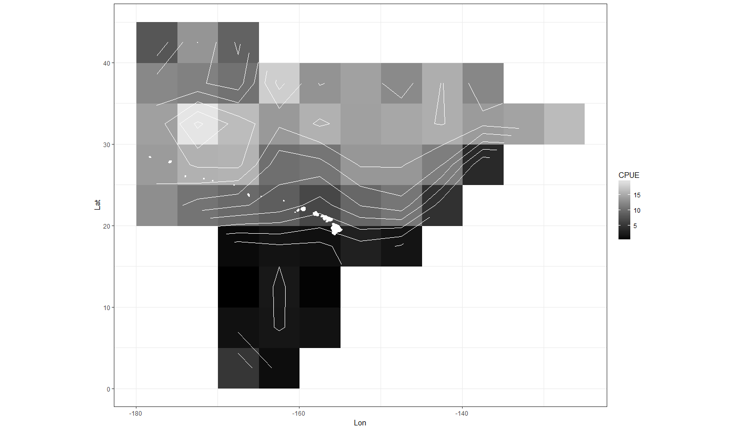

Figure 1. Overall mean nominal swordfish CPUE (# swordfish/1000 hooks) by 5 × 5° square for the Hawaii-based longline shallow-set fishery from the Pacific Islands Regional Observer Program data set. Squares with fewer than three vessels have been excluded from the plot for confidentiality. Contours indicate a change of 2 CPUE values. The Hawaii archipelago is plotted in left half along the center of the plot in white.

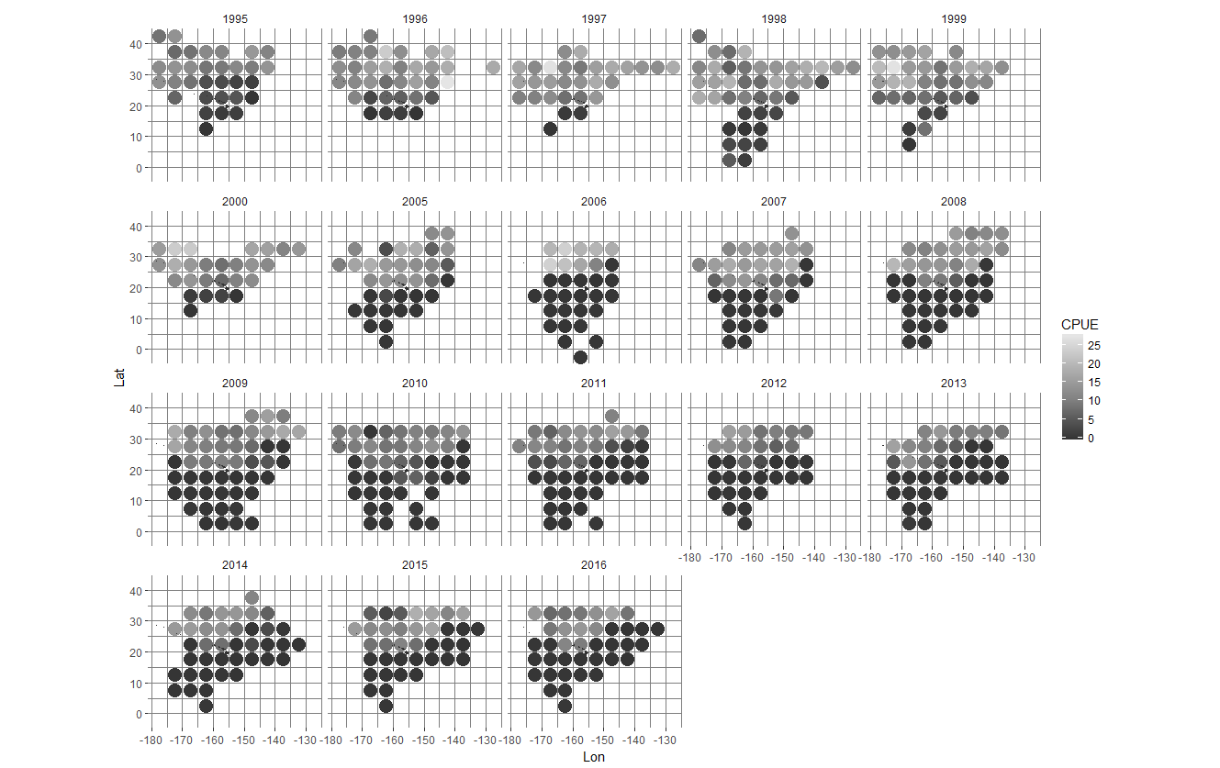

Figure 2. Annual mean nominal swordfish CPUE (# swordfish/1000 hooks) for the Hawaii-based longline shallow-set fishery in 5 × 5° squares from the Pacific Islands Regional Observer Program data set. Squares with fewer than three vessels have been excluded from the plot for confidentiality. Years 2001–2004 are not plotted due to the fishery closure.

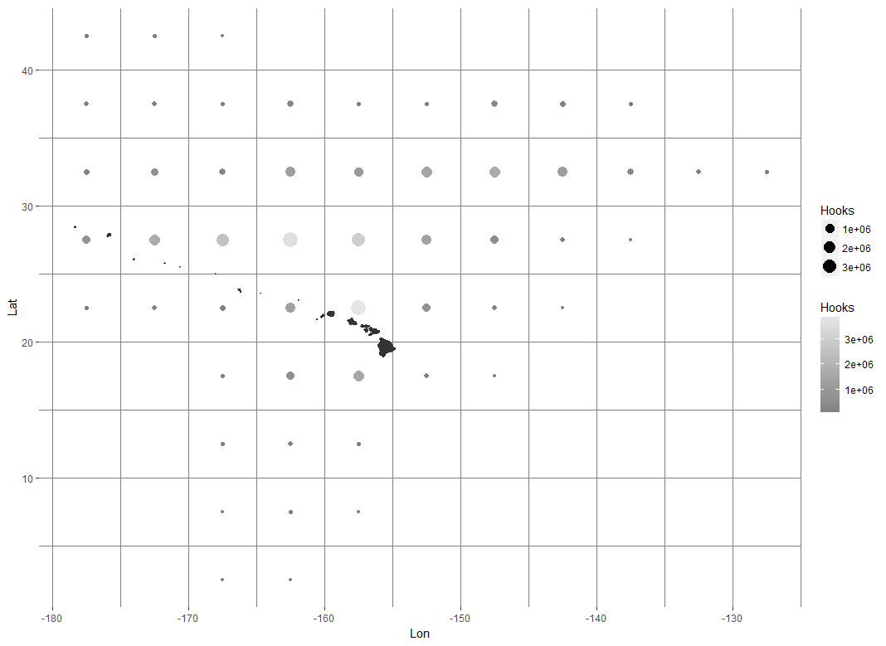

Figure 3. Total number of hooks set in 5 × 5° squares by the Hawaii-based longline shallow-set fishery using data from 1995-2000 and 2005-2016 using the Pacific Islands Regional Observer Program data set. Squares with fewer than three vessels were excluded from the plot for confidentiality.

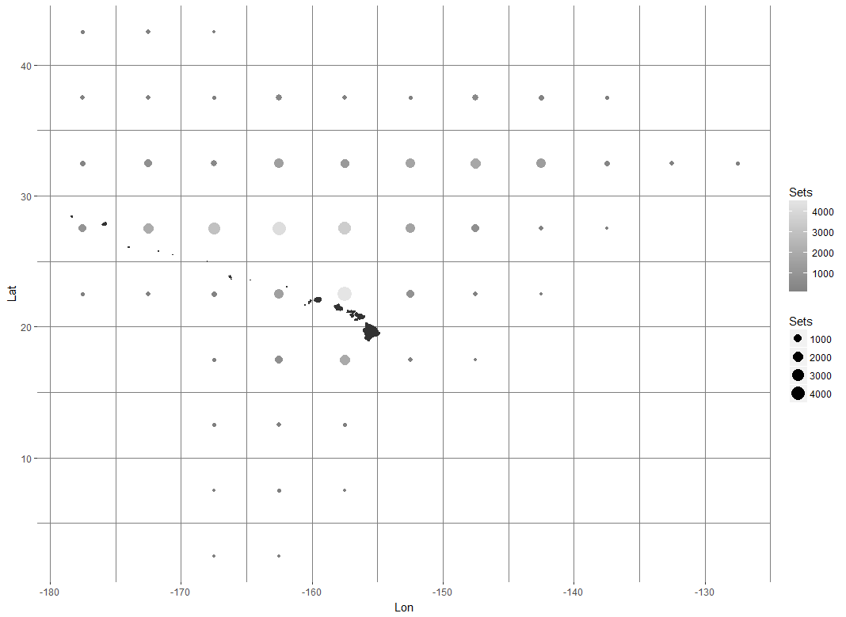

Figure 4. Total number of sets recorded in 5 × 5° squares by the Hawaii-based longline shallow-set fishery using data from 1995–2000 and 2005–2016 using the Pacific Islands Regional Observer Program data set. Squares with fewer than three vessels reporting sets were excluded from the plot for confidentiality.

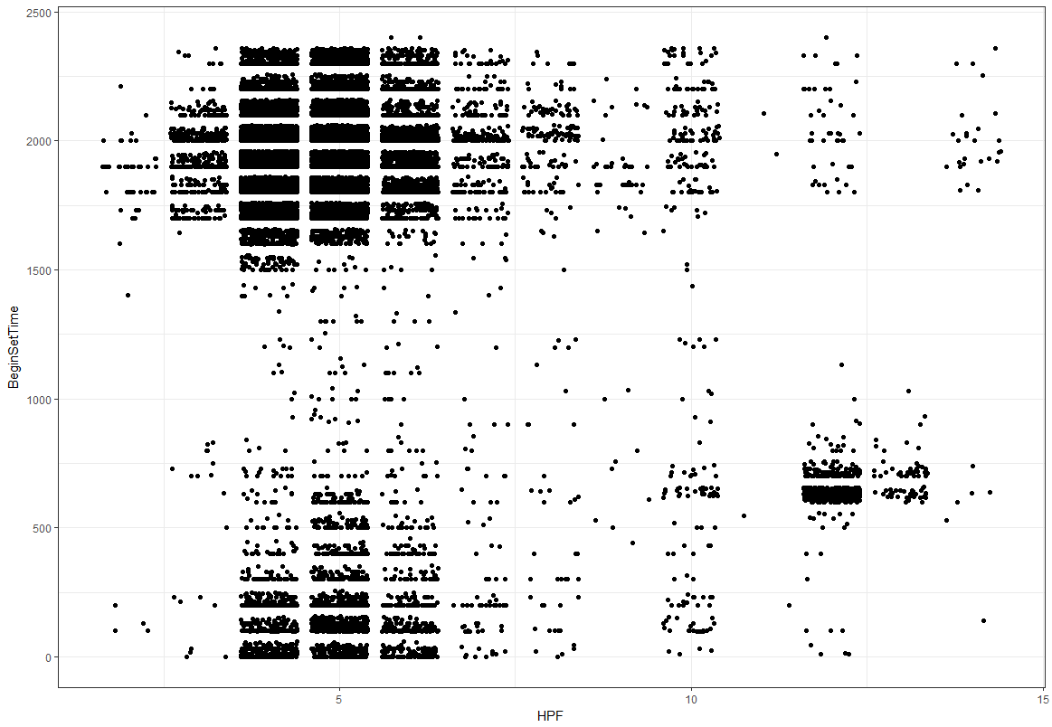

Figure 5. Begin set time vs number of hooks per float for the Hawaii longline shallow-set fishery. Points are “jittered” so that the density of points can be seen at each set time/HPF combination.

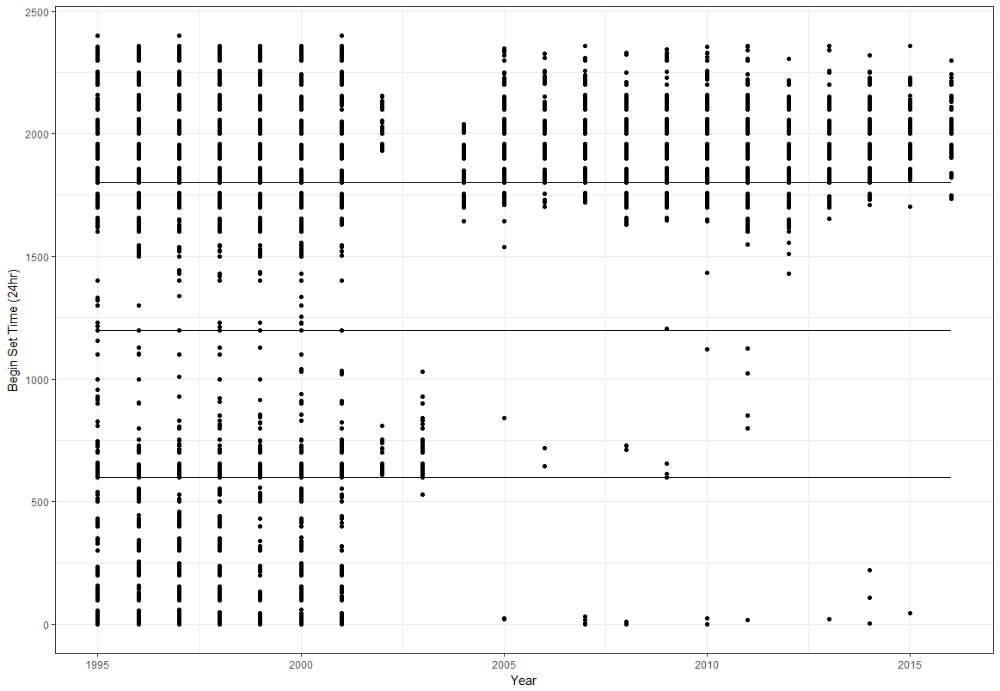

Figure 6. Begin set time by year for the Hawaiian longline shallow-set fishery.

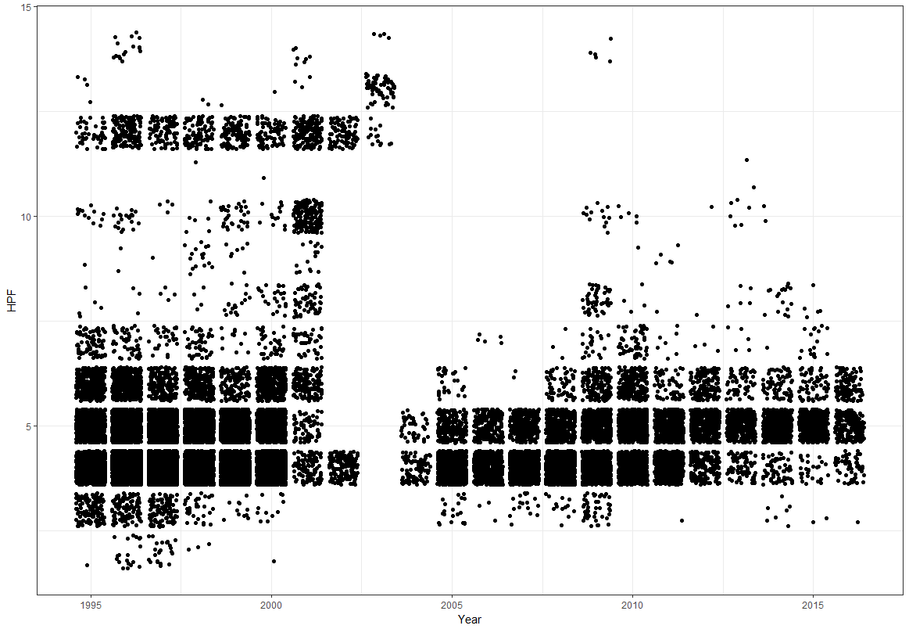

Figure 7. Jitter plot showing the number of hooks per float by year for the Hawaiian longline shallow-set fishery. Both hooks per float and year were discrete variables, the spread of points is to show the density of each year/HPF combination.

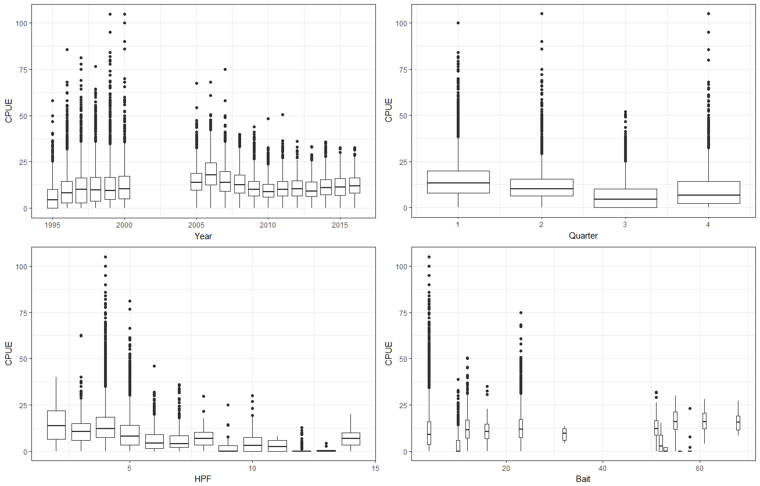

Figure 8. Boxplots of nominal swordfish CPUE (# swordfish/1000 hooks) by year (top left), quarter (top right), hooks per float (bottom left), and bait type (bottom right) for the Hawaii-based longline shallow-set fishery.

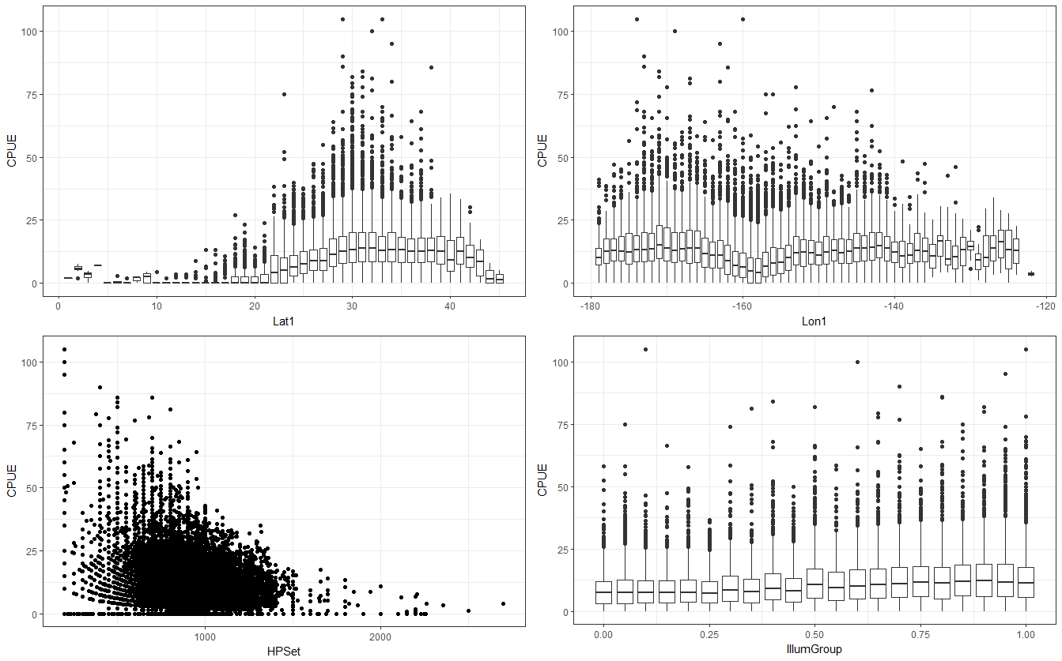

Figure 9. Boxplots of nominal swordfish CPUE (# swordfish/1000 hooks) by longitude (top left) and latitude (top right). Plots of CPUE vs hooks per set (bottom left) and lunar illumination (bottom right) for the Hawaii-based longline shallow-set fishery.

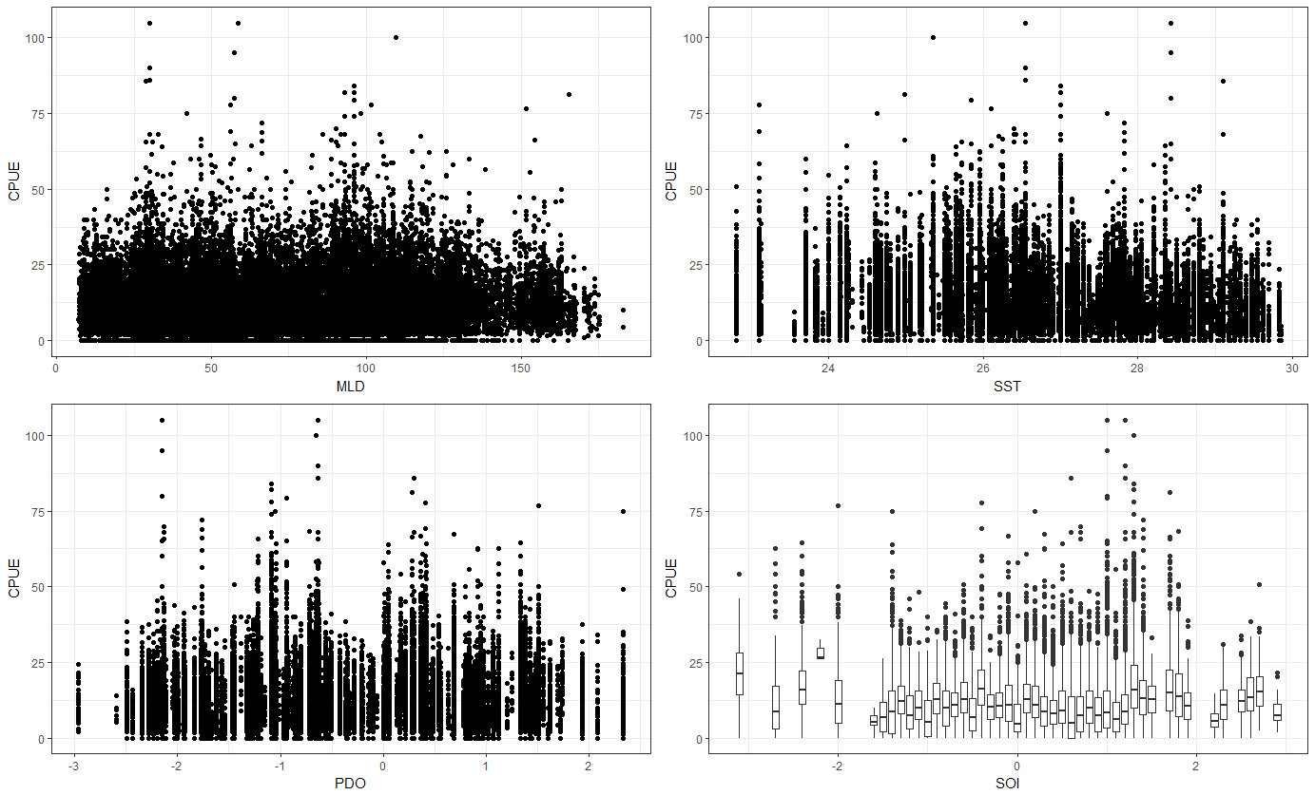

Figure 10. Plots of nominal swordfish CPUE (# swordfish/1000 hooks) by the mixed layer depth (top left), sea surface temperature (top right), and the Pacific Decadal Oscillation index (bottom left) and a boxplot of CPUE versus the Southern Oscillation Index (bottom right) for the Hawaii-based longline shallow-set fishery.

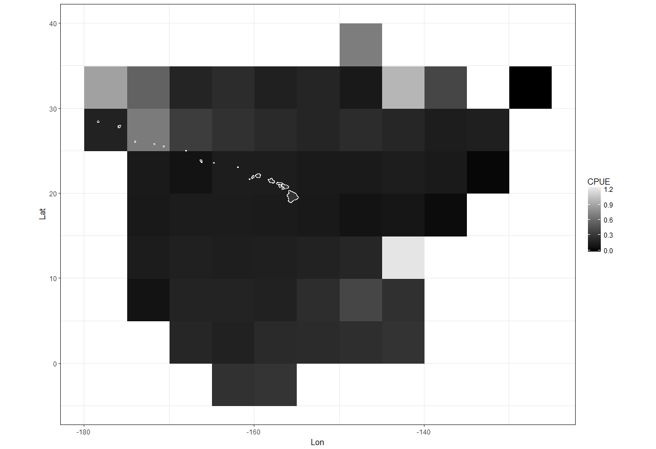

Figure 11. Overall mean nominal swordfish CPUE (# swordfish/1000 hooks) by 5 × 5° square for the Hawaii-based longline deep-set fishery from the Pacific Islands Regional Observer Program data set. Squares with fewer than three vessels have been excluded from the plot for confidentiality. The Hawaiian Archipelago is plotted in left half along the center of the plot.

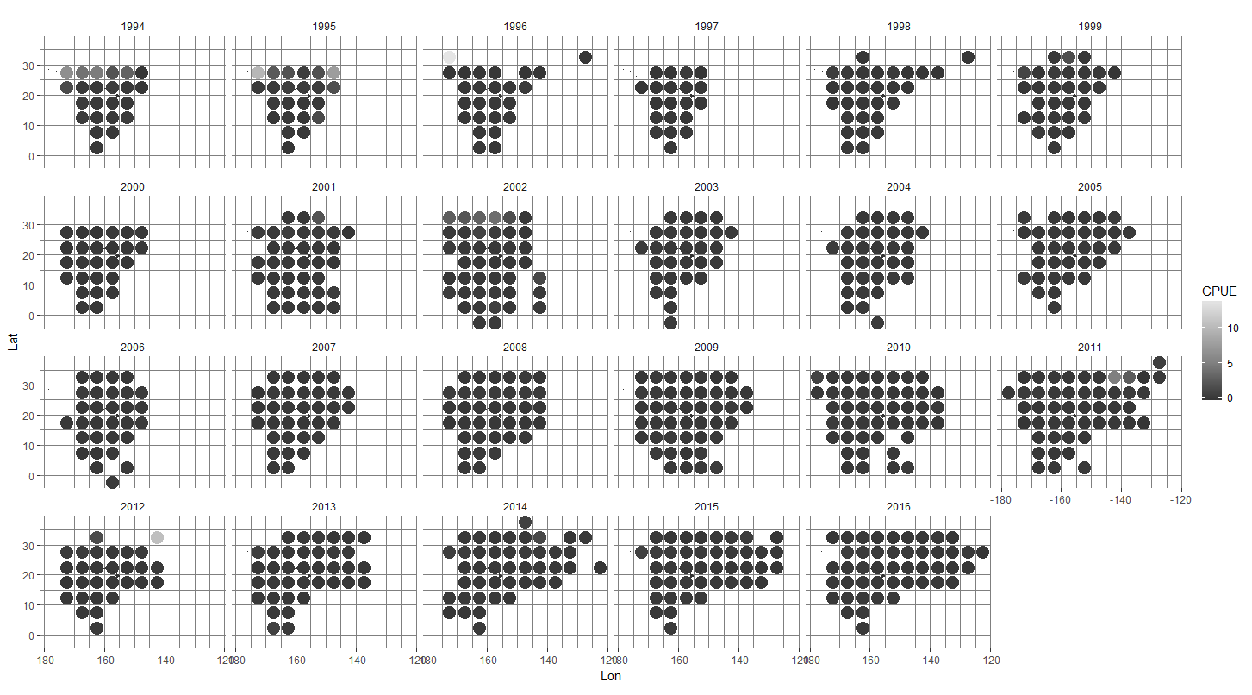

Figure 12. Annual mean nominal swordfish CPUE (# swordfish/1000 hooks) for the Hawaii-based longline deep-set fishery in 5 × 5° squares from the Pacific Islands Regional Observer Program data set. Squares with fewer than three vessels have been excluded from the plot for confidentiality.

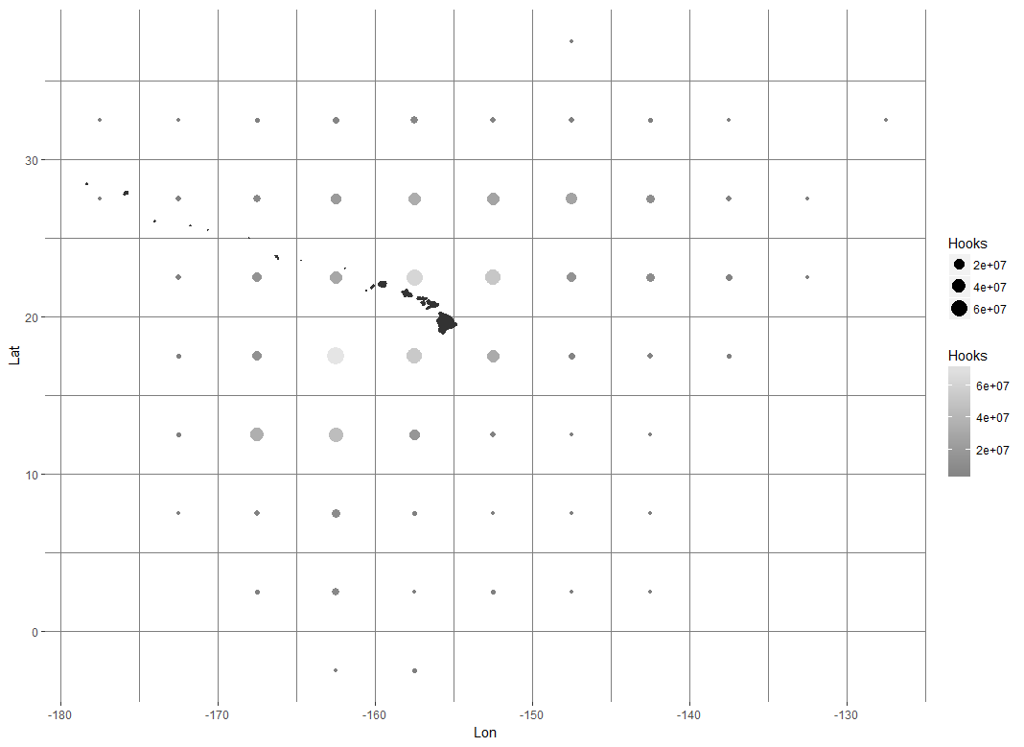

Figure 13. Total number of hooks set in 5 × 5° squares by the Hawaii-based longline deep-set fishery from 1995 to 2016 using the Pacific Islands Regional Observer Program data set. Squares with fewer than three vessels reporting sets were excluded from the plot for confidentiality.

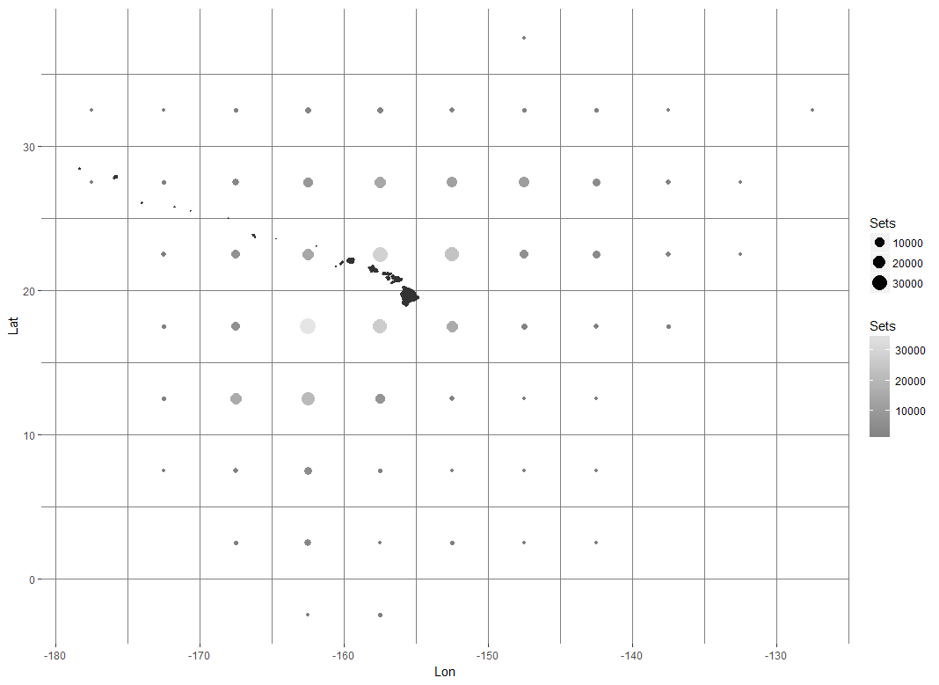

Figure 14. Total number of sets recorded in 5 × 5° squares by the Hawaii-based longline deep-set fishery from 1995–2016 using the Pacific Islands Regional Observer Program data set. Squares with fewer than three vessels reporting sets were excluded from the plot for confidentiality.

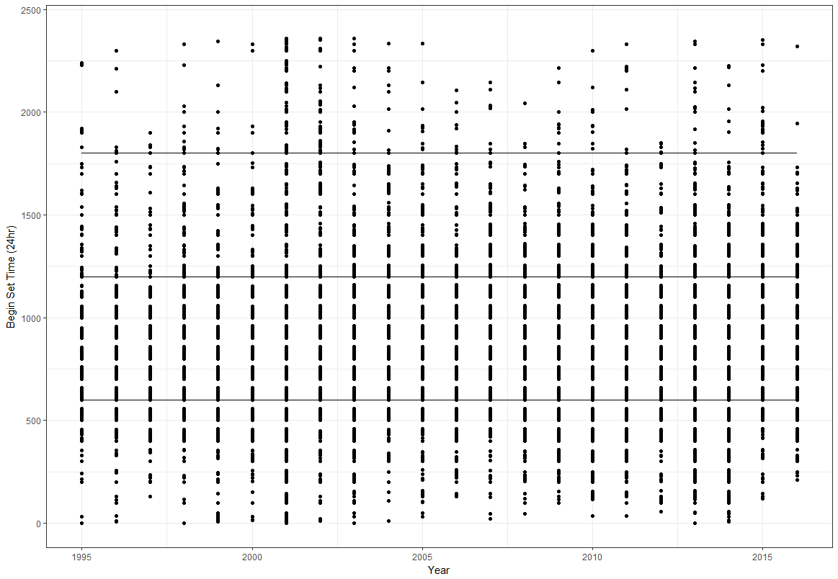

Figure 15. Begin set time by year for the Hawaiian longline deep-set fishery.

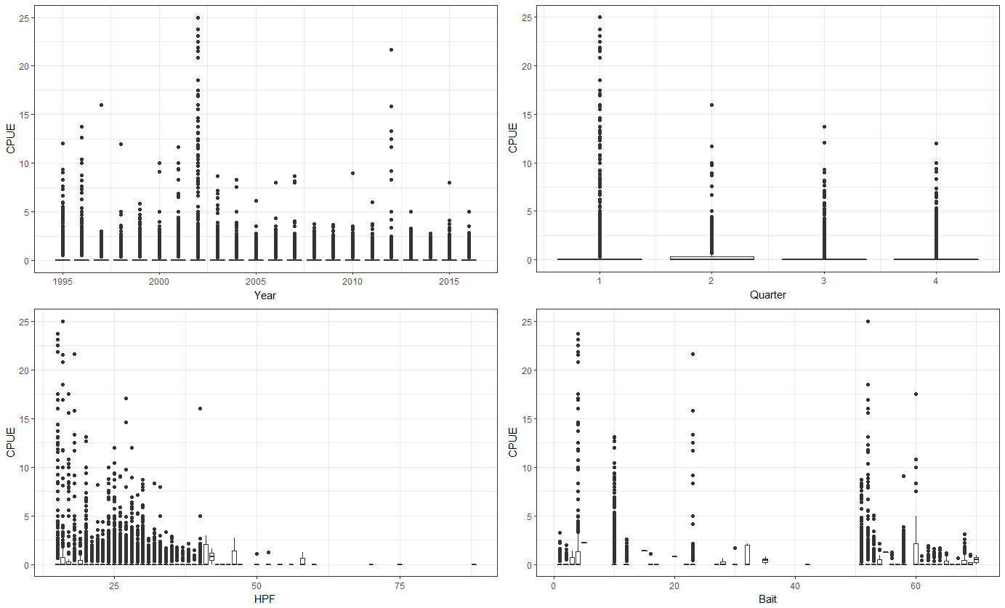

Figure 16. Boxplots of nominal swordfish CPUE (# swordfish/1000 hooks) by year (top left), quarter (top right), hooks per float (bottom left), and bait type (bottom right) for the Hawaii-based longline deep-set fishery.

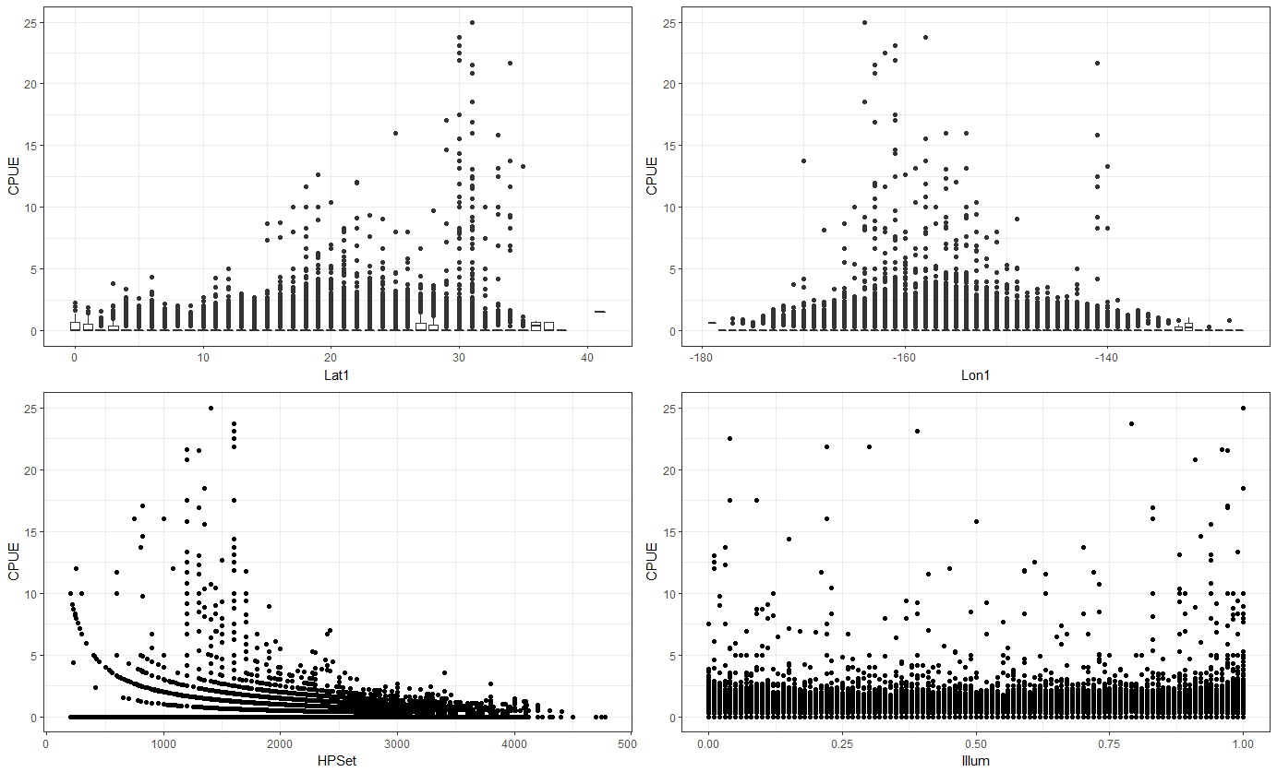

Figure 17. Boxplots of nominal swordfish CPUE (# swordfish/1000 hooks) by longitude (top left) and latitude (top right). Plots of CPUE vs hooks per set (bottom left) and lunar illumination (bottom right) for the Hawaii-based longline deep-set fishery.

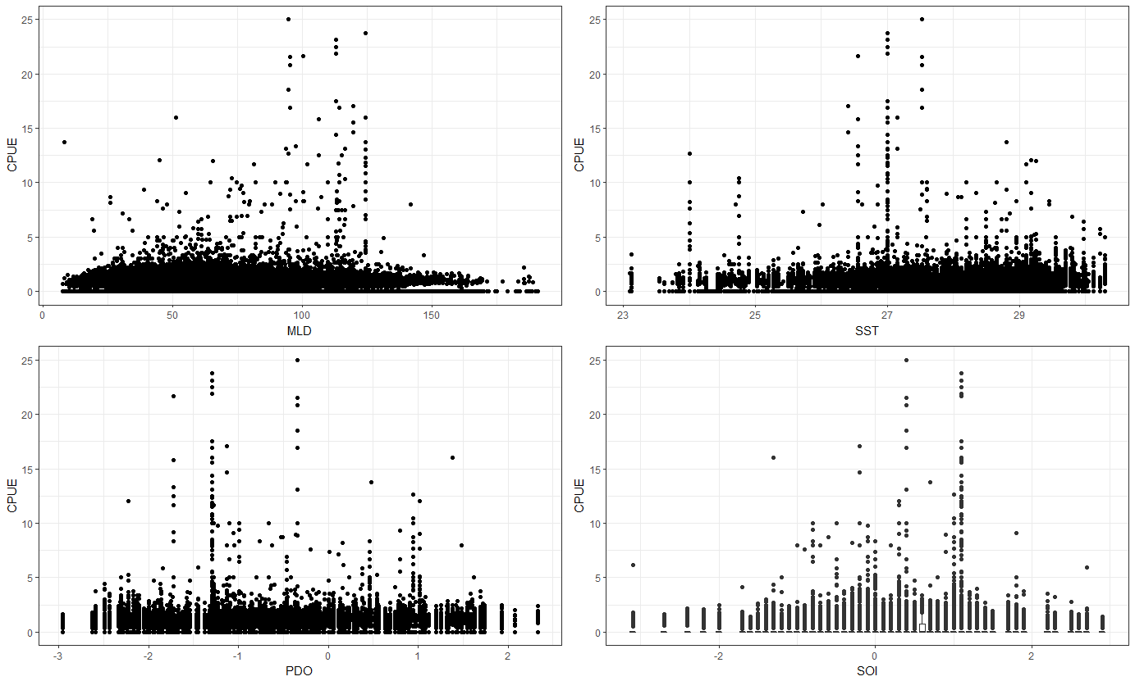

Figure 18. Plots of nominal swordfish CPUE (# swordfish/1000 hooks) by the mixed layer depth (top left), sea surface temperature (top right), and the Pacific Decadal Oscillation index (bottom left) and a boxplot of CPUE vs. the Southern Oscillation Index (bottom right) for the Hawaii-based longline deep-set fishery.

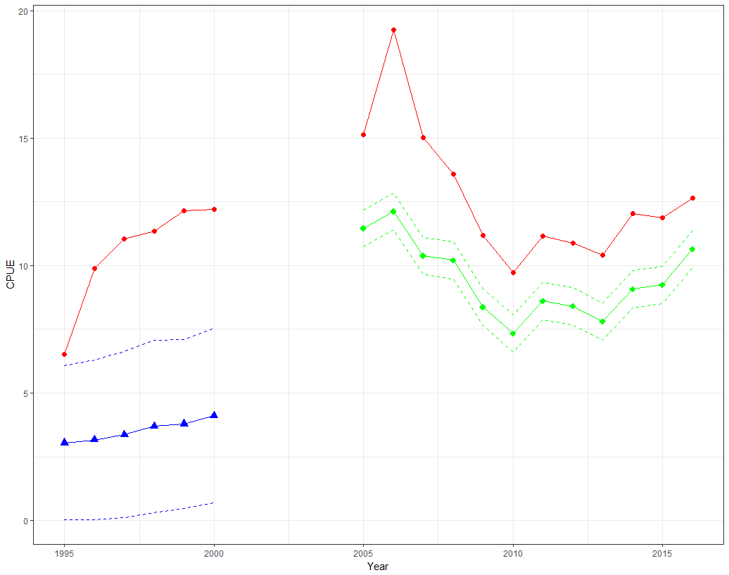

Figure 19. Nominal (red circles) and standardized swordfish CPUE (# swordfish/1000 hooks) for the early (blue triangles) and late (green diamonds) time series from the Hawaii-based longline shallow-set fishery Pacific Islands Regional Observer Program data set. Dashed lines indicate 95% confidence intervals around the standardized CPUE values.

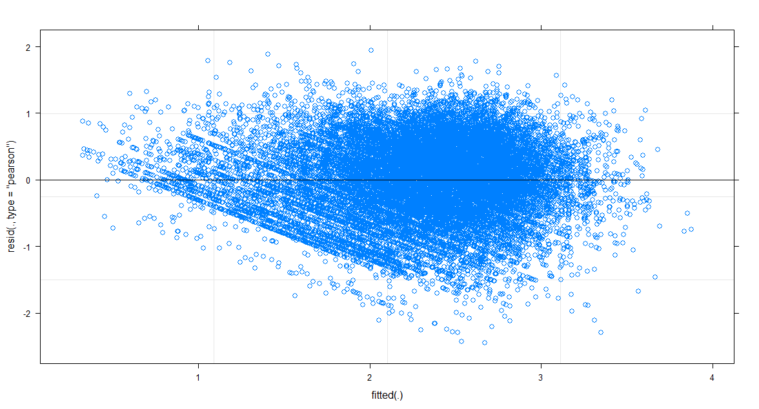 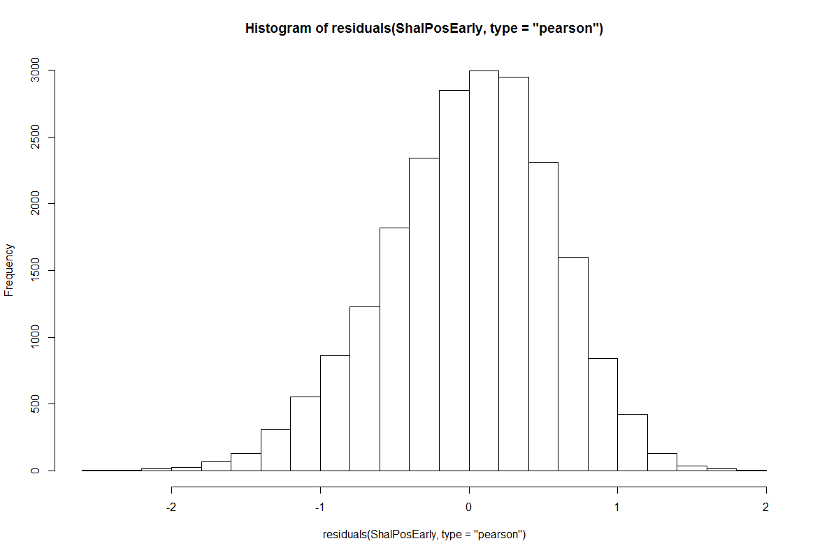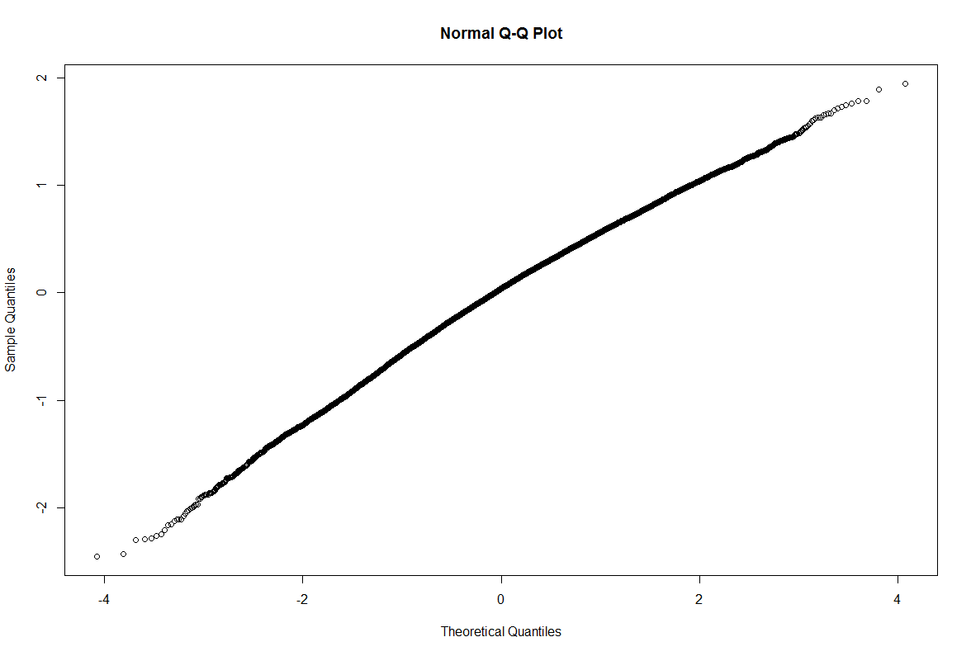

Figure 20. Diagnostic plots from the lognormal model of the positive swordfish catches in the Hawaii-based longline shallow-set fishery in the early period (1995–2000): A scatterplot of Pearson residuals (Upper left), a histogram of Pearson Residuals (top right) and a Q-Q plot (bottom left).

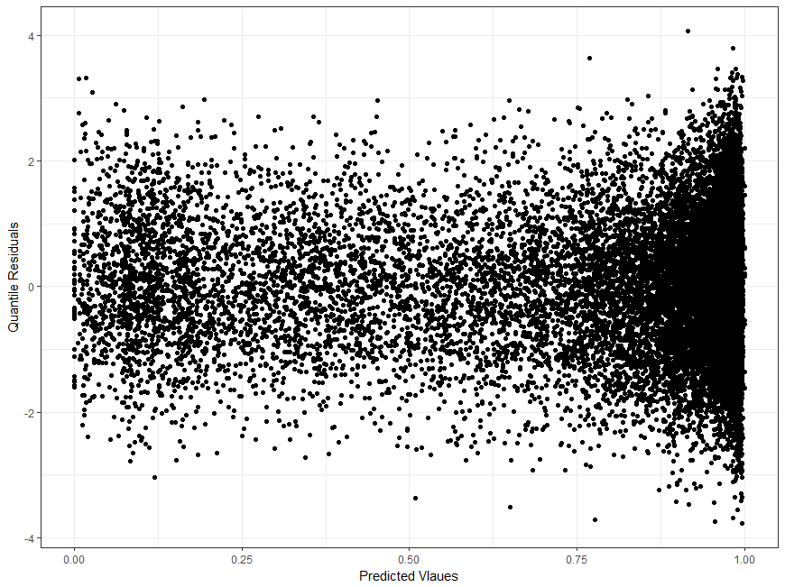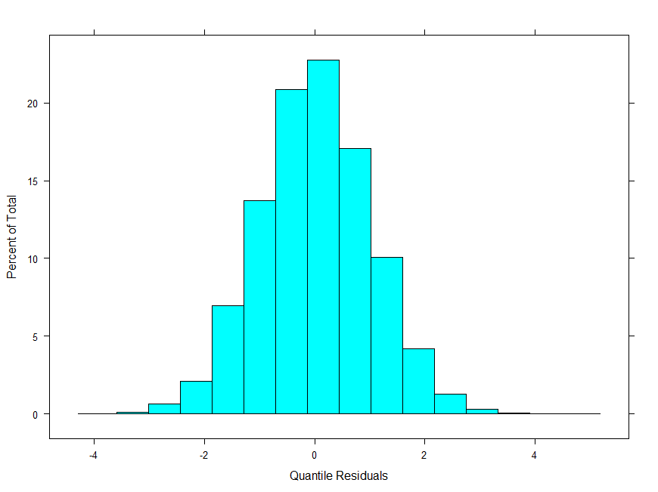

Figure 21. Diagnostic plots from the binomial model of the proportion positive swordfish catches in the Hawaii-based longline shallow-set fishery in the early period (1995–2000): A scatterplot of Quantile residuals (left), a histogram of Quantile Residuals (right)

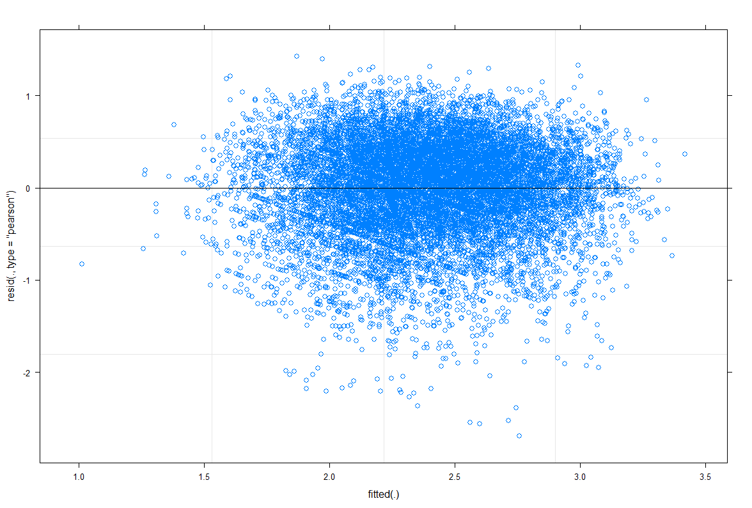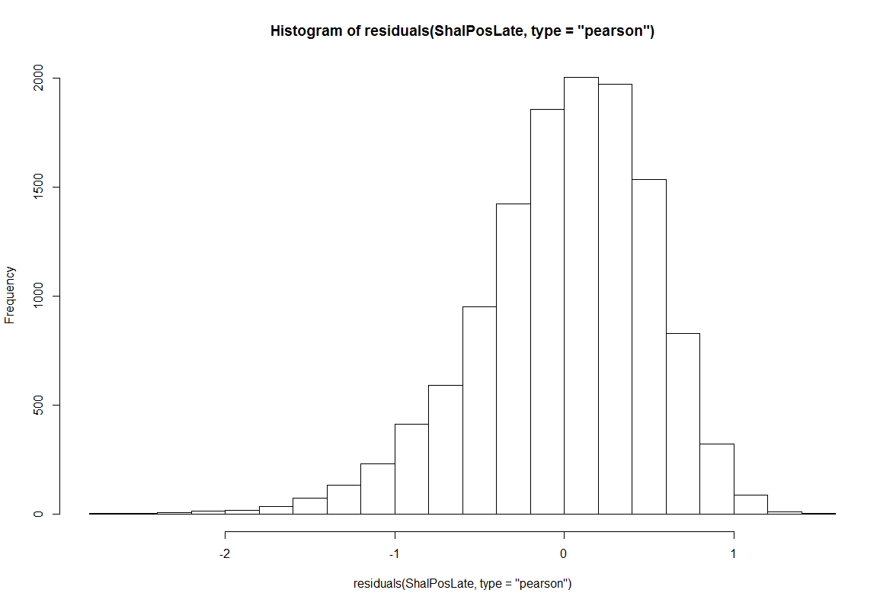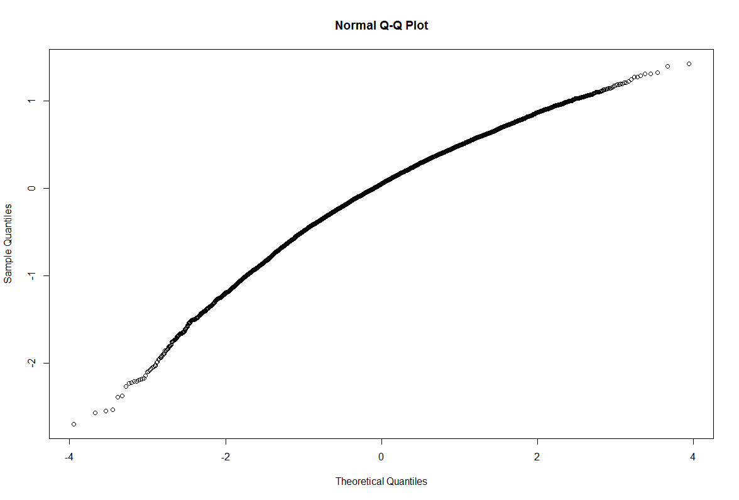

Figure 22. Diagnostic plots from the lognormal model of the positive swordfish catches of the Hawaii-based longline shallow-set fishery in the late period (2005–2016): A scatterplot of Pearson residuals (Upper left), a histogram of Pearson Residuals (top right) and a Q-Q plot (bottom left).

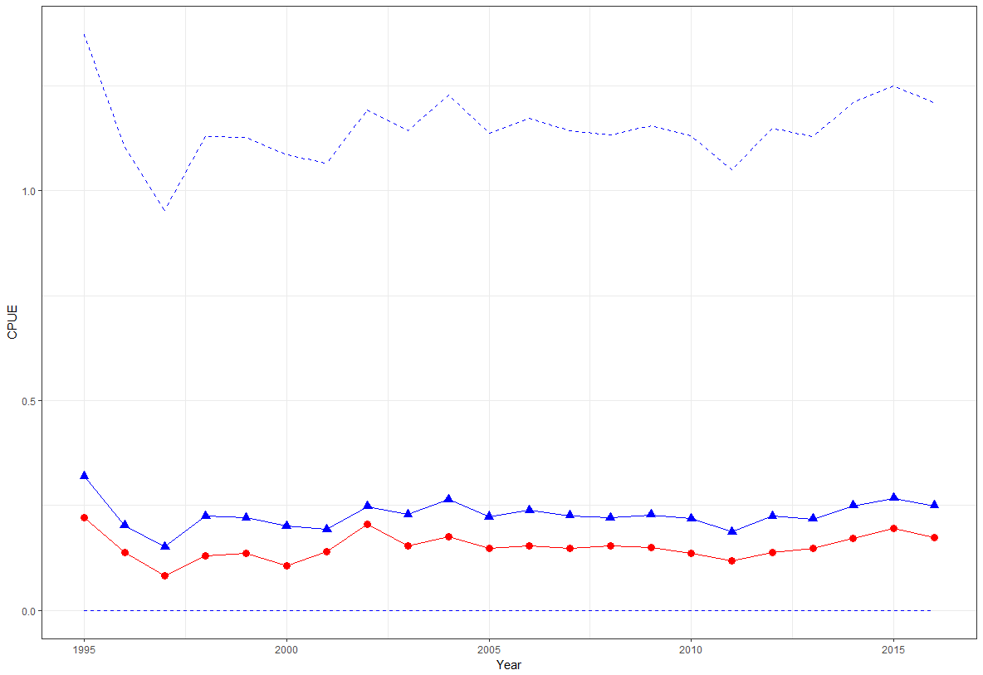

Figure 23. Nominal (red circles) and standardized (blue triangles) swordfish CPUE (#swordfish/1000 hooks) from the Hawaii-based longline deep-set fishery Pacific Islands Regional Observer Program data set. Dashed lines indicate 95% confidence intervals around the standardized CPUE values.

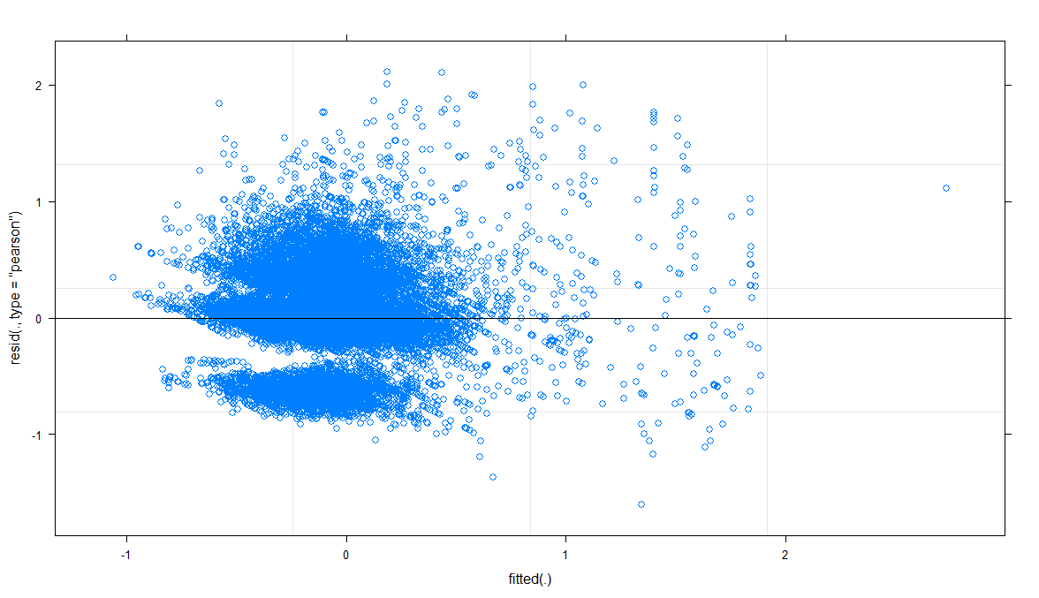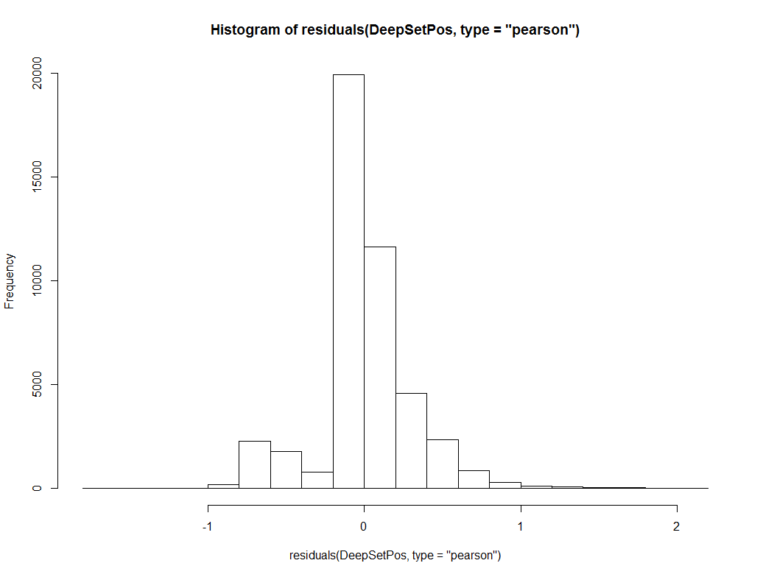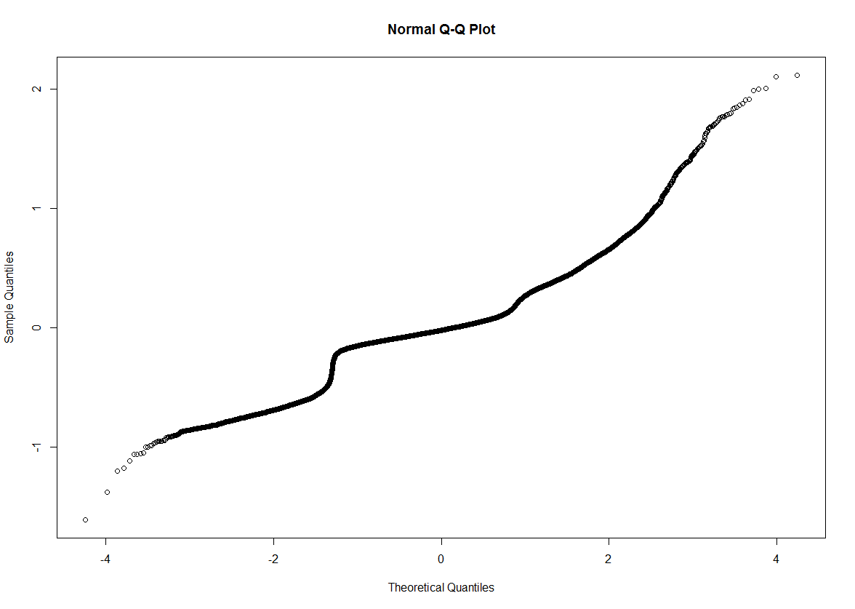

Figure 24. Diagnostic plots from the lognormal model of the positive swordfish catches in the Hawaii-based longline deep-set fishery: A scatterplot of Pearson residuals (Upper left), a histogram of Pearson Residuals (top right) and a Q-Q plot (bottom left).

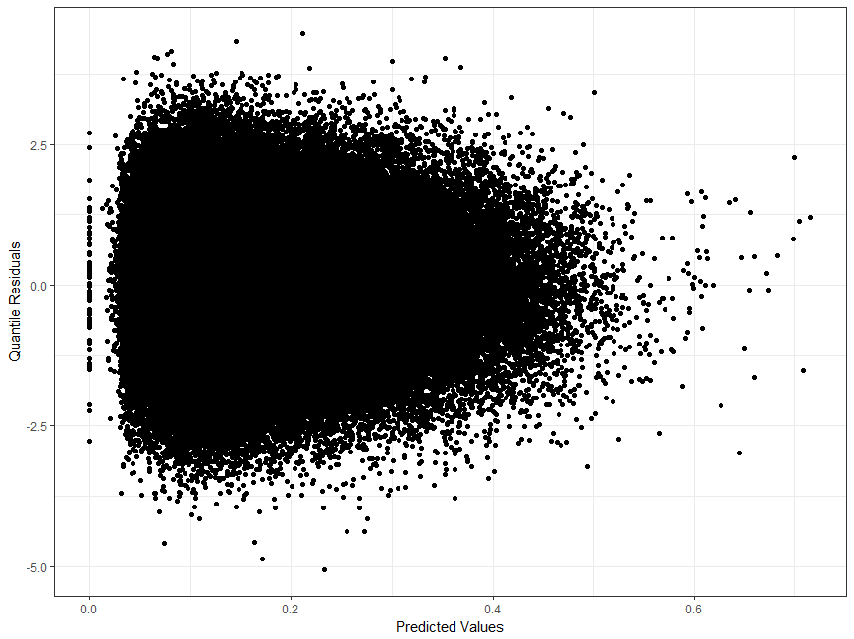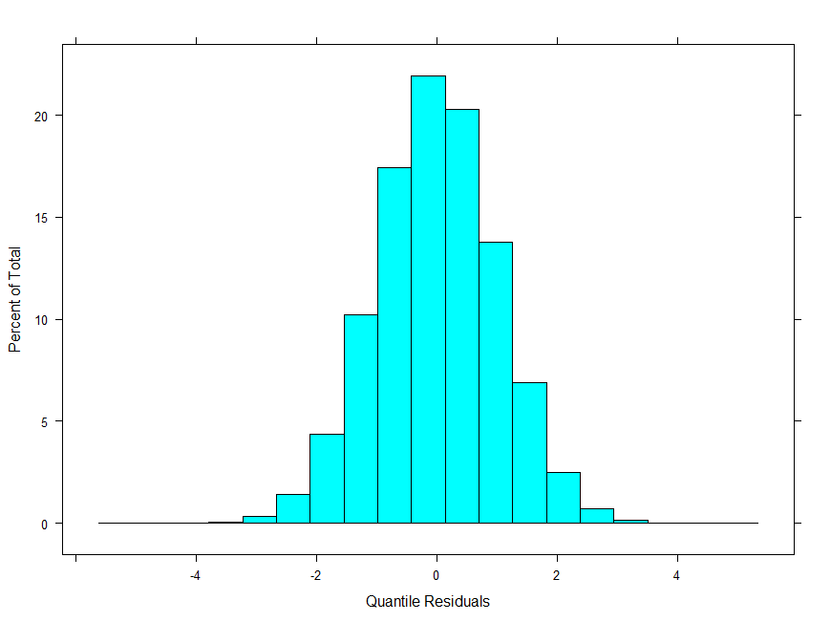

Figure 25. Diagnostic plots from the binomial model of the proportion positive swordfish catches in the Hawaii-based longline deep-set fishery: A scatterplot of Quantile residuals (left), a histogram of Quantile Residuals (right)

# **Appendices**

## Residual patterns of standardized swordfish CPUE (# swordfish/1000 hooks) by each variable for the Lognormal GLM on the Hawaii-based longline shallow-set fishery in the early period (1995–2000) from the Pacific Islands Regional Observer Program data set.

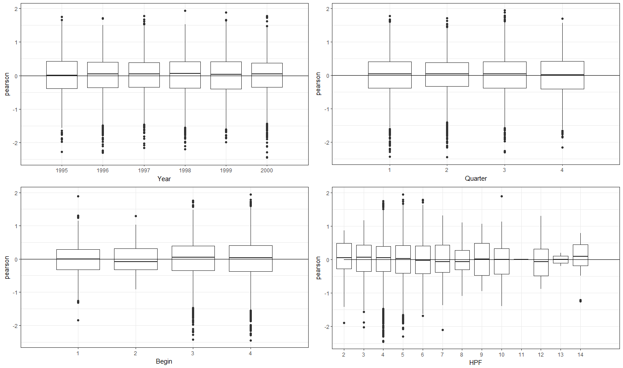

Figure A1. Pearson residuals by year (top left), Quarter (top right), Begin set time (bottom left), and number of hooks per float (bottom right). Solid lines indicate 0.

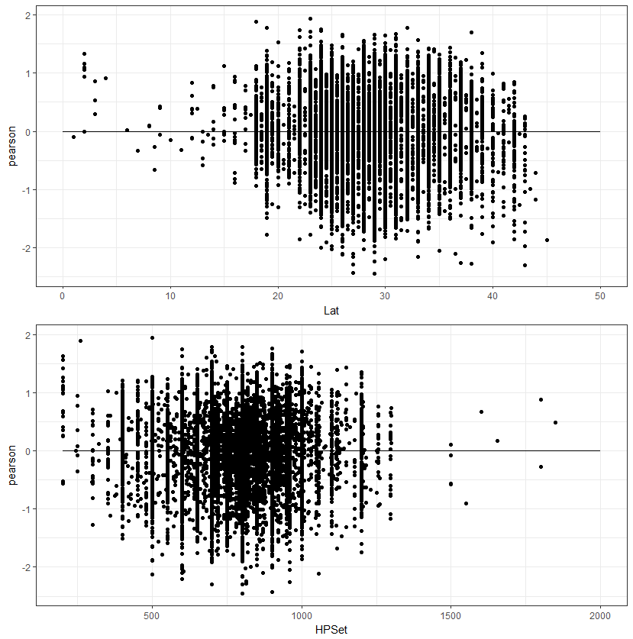

Figure A2. Pearson residuals by latitude (top) and number of hooks per set (bottom). Solid lines indicate 0.

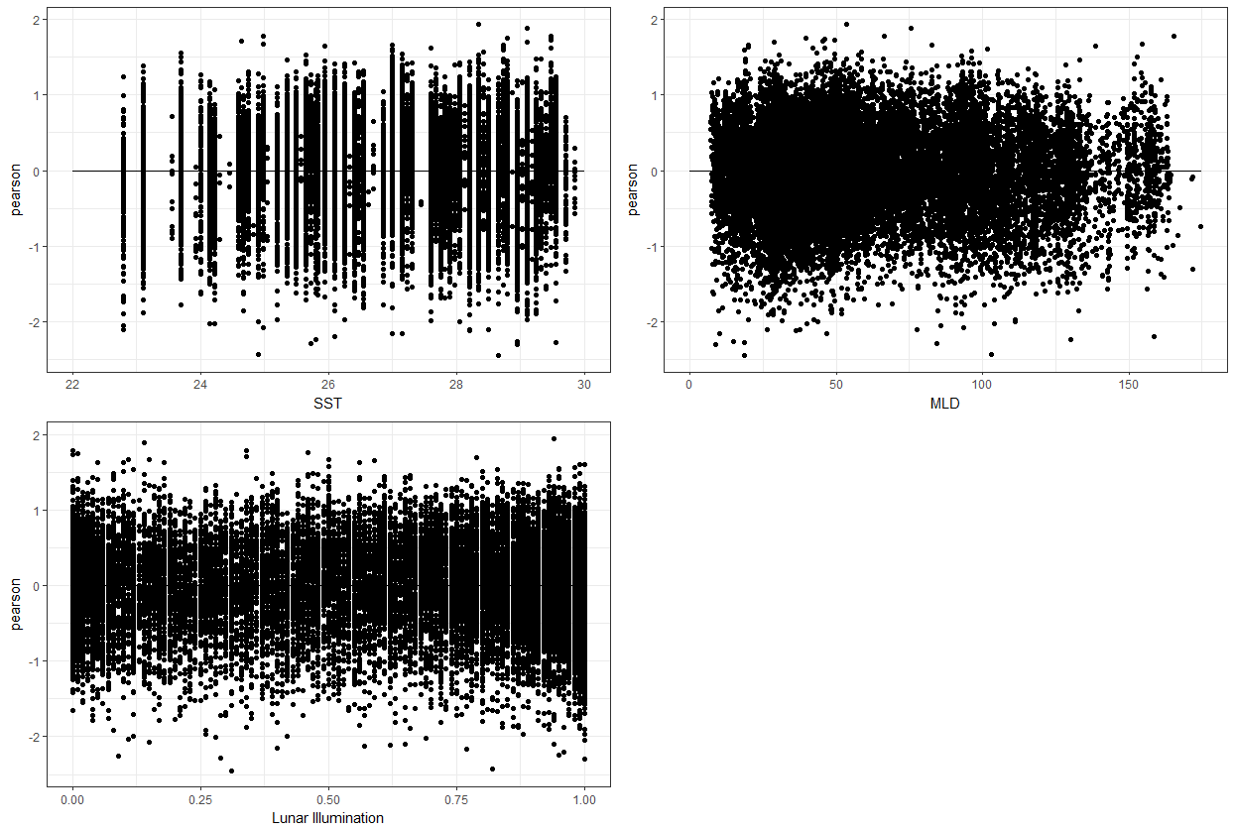

Figure A3. Pearson residuals by sea surface temperature (top left), mixed layer depth (top right), and lunar illumination (bottom left). Solid lines indicate 0.

## Residual patterns of standardized swordfish CPUE (# swordfish/1000 hooks) by each variable for the Binomial GLM on the Hawaii-based longline shallow-set fishery in the early period (1995–2000) from the Pacific Islands Regional Observer Program data set.

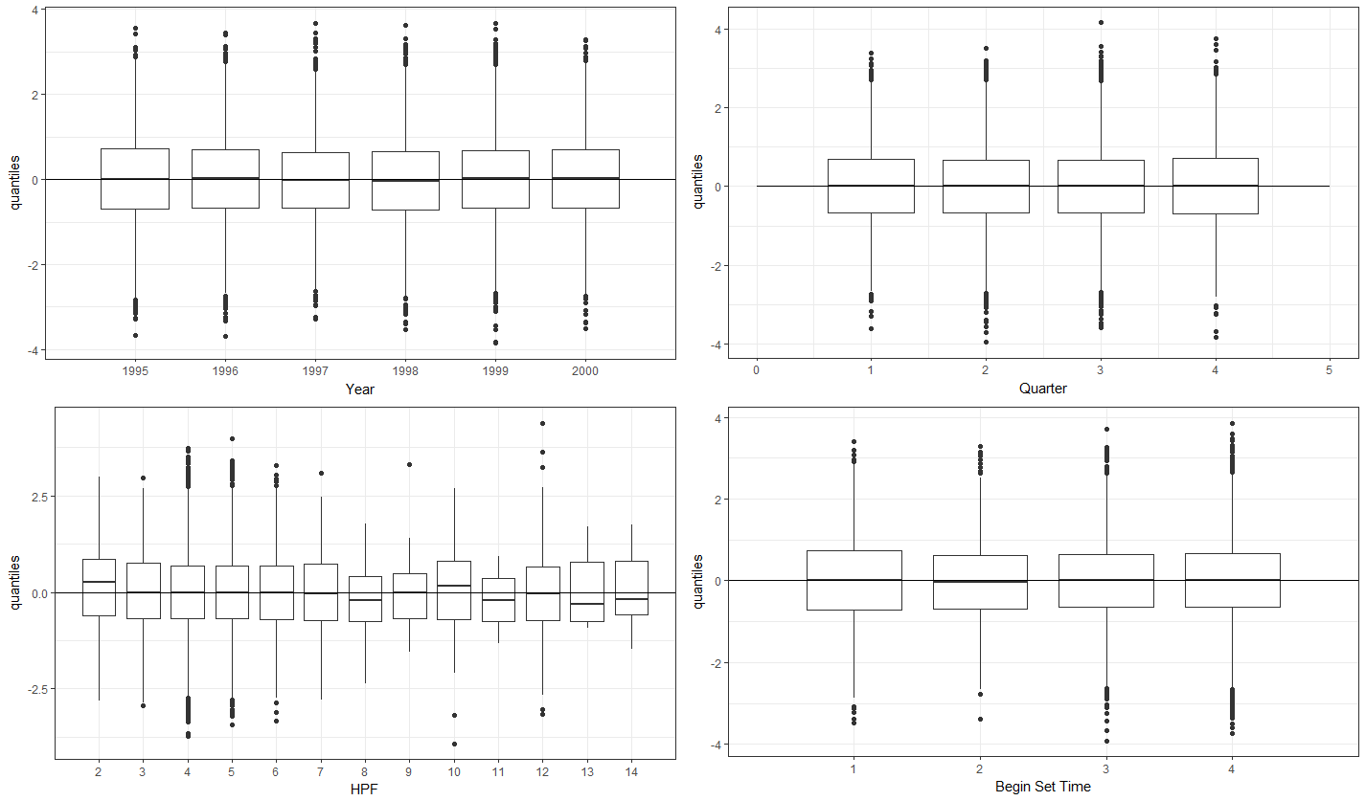

Figure A4. Pearson residuals by year (top left), Quarter (top right), number of hooks per float (bottom left), and begin set time (bottom right). Solid lines indicate 0.

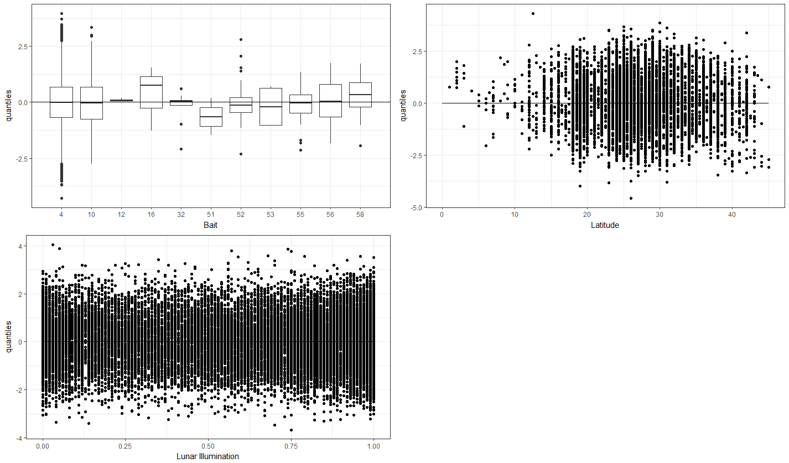

Figure A5. Pearson residuals by bait type (top left), latitude (top right), and lunar illumination (bottom left). Solid lines indicate 0.

## Residual patterns of standardized swordfish CPUE (# swordfish/1000 hooks) by each variable for the Lognormal GLM on the Hawaii-based longline shallow-set fishery in the late period (2005–2016) from the Pacific Islands Regional Observer Program data set.

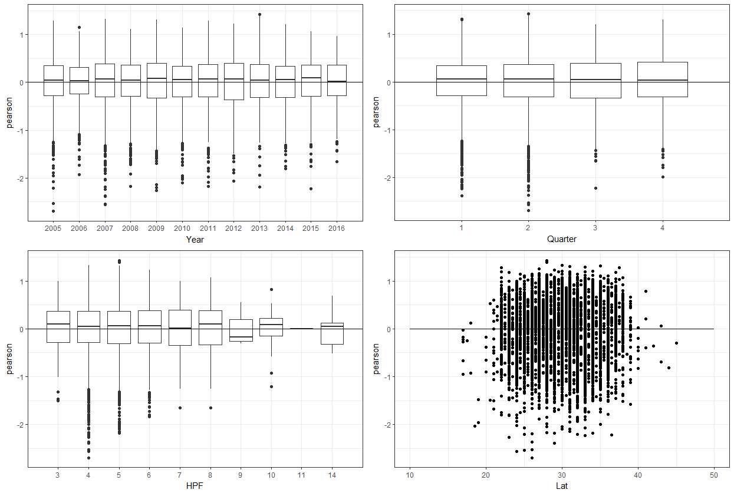

Figure A 6. Pearson residuals by year (top left), Quarter (top right), number of hooks per float (bottom left), and latitude (bottom right). Solid lines indicate 0.

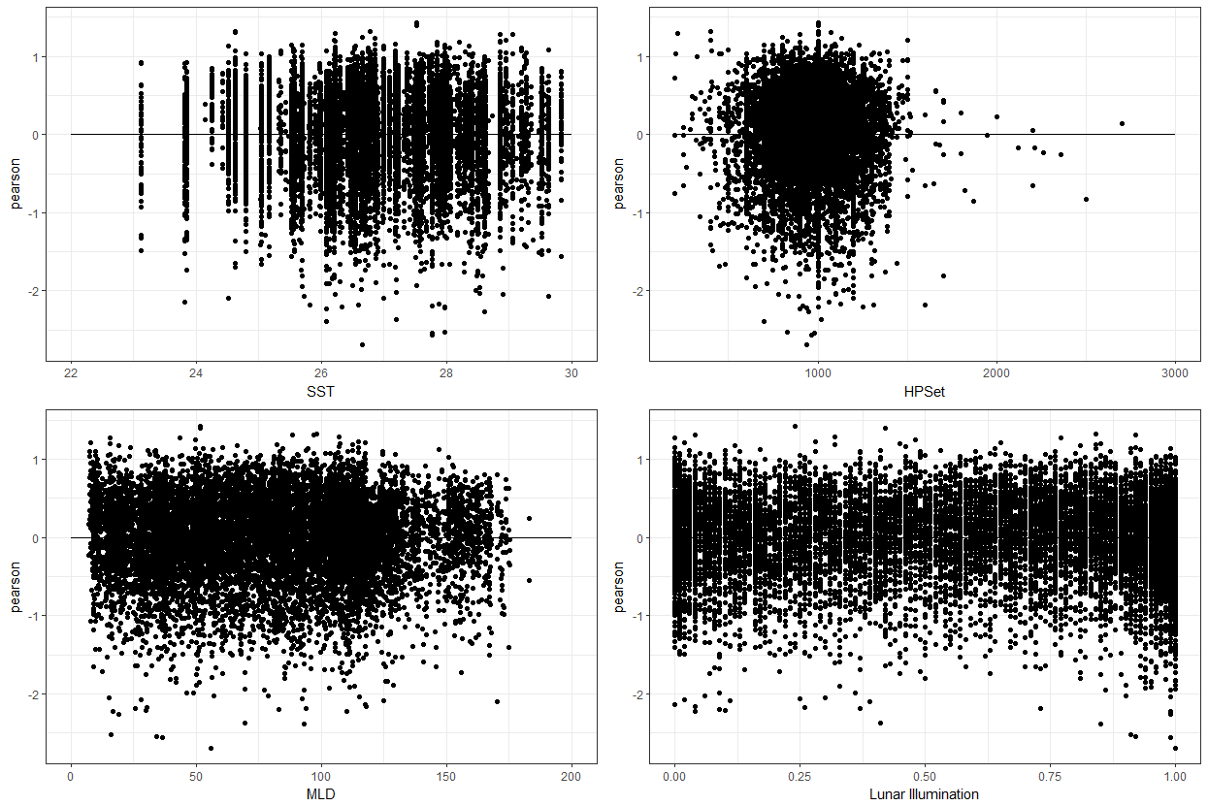

Figure A 7. Pearson residuals by sea surface temperature (top left), number of hooks per set (top right), mixed layer depth (bottom left), and lunar illumination (bottom right). Solid lines indicate 0.

## Residual patterns of standardized swordfish CPUE (# swordfish/1000 hooks) by each variable for the Lognormal GLM on the Hawaii-based longline deep-set fishery from the Pacific Islands Regional Observer Program data set.

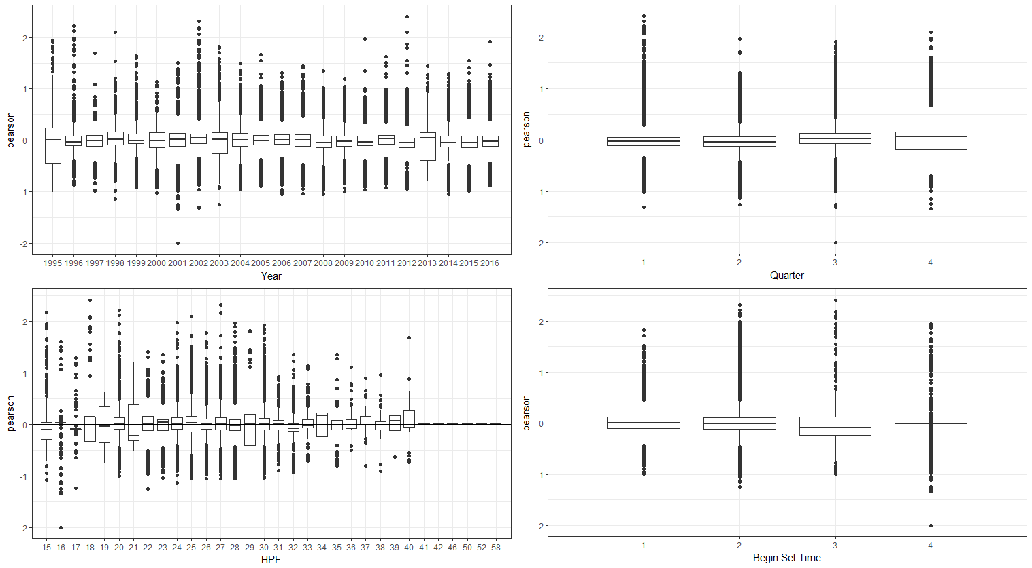

Figure A8. Pearson residuals by year (top left), Quarter (top right), number of hooks per float (bottom left), and begin set time (bottom right). Solid lines indicate 0.

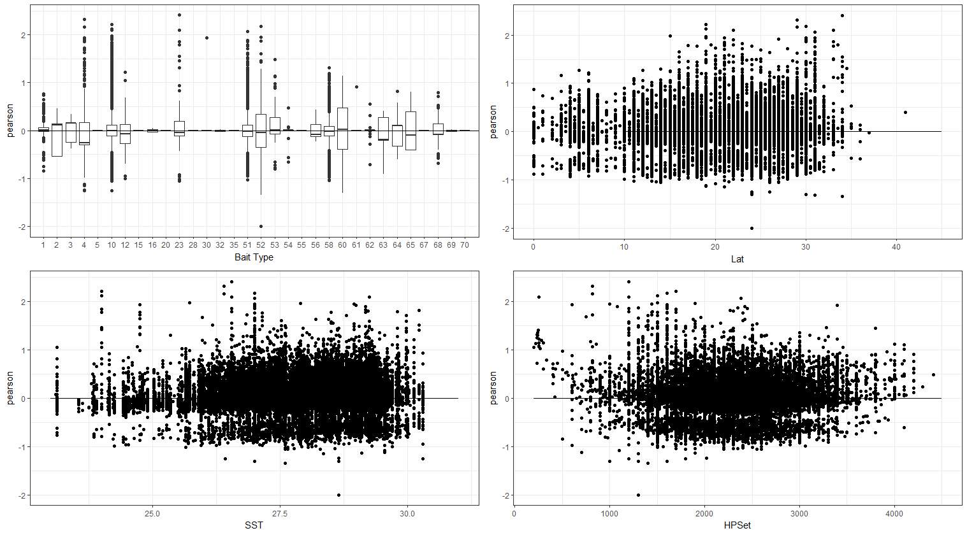

Figure A9. Pearson residuals by bait type (top left), latitude (top right), sea surface temperature (bottom left), and number of hooks per set (bottom right). Solid lines indicate 0.

## Residual patterns of standardized swordfish CPUE (# swordfish/1000 hooks) by each variable for the Lognormal GLM on the Hawaii-based longline deep-set fishery from the Pacific Islands Regional Observer Program data set.

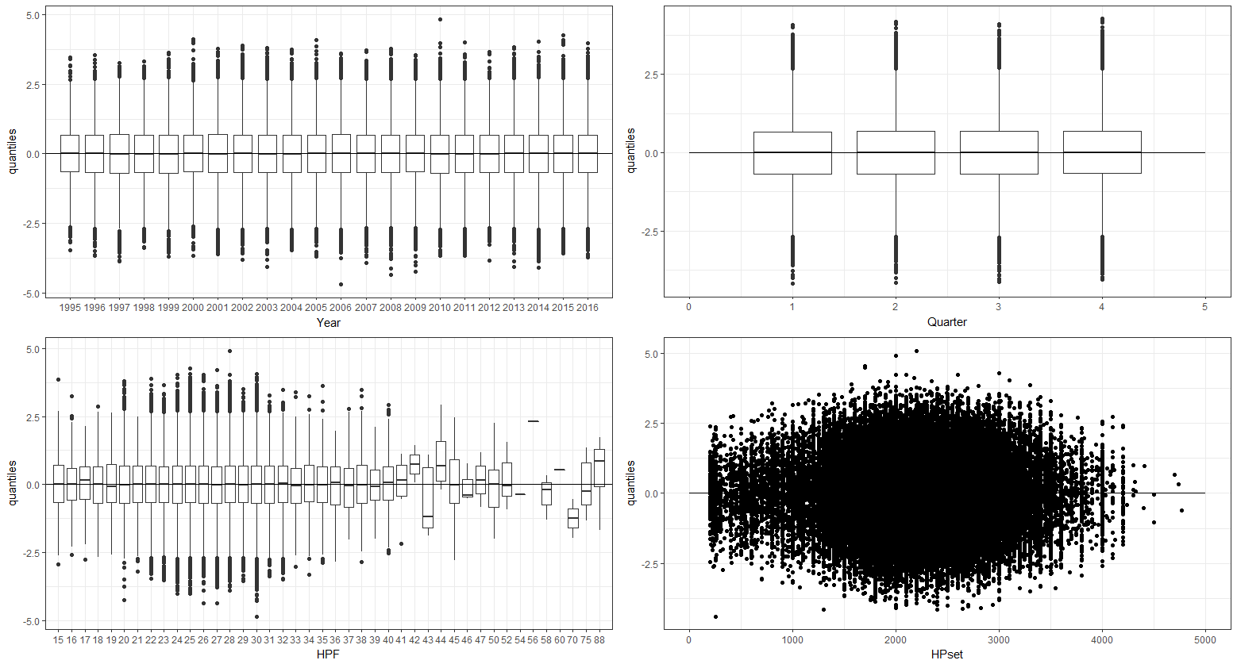

Figure A10. Pearson residuals by year (top left), Quarter (top right), number of hooks per float (bottom left), and number of hooks per set (bottom right). Solid lines indicate 0.

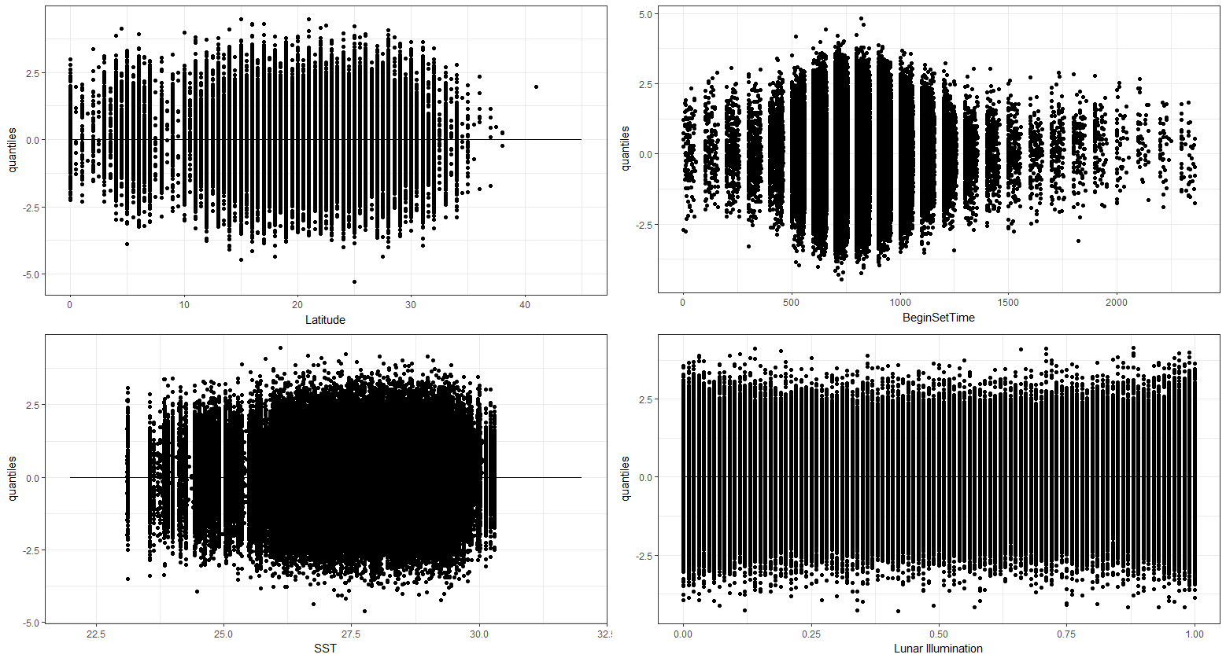

Figure A11. Pearson residuals by latitude (top left), begin set time (top right), sea surface temperature (bottom left), and lunar illumination (bottom right). Solid lines indicate 0.

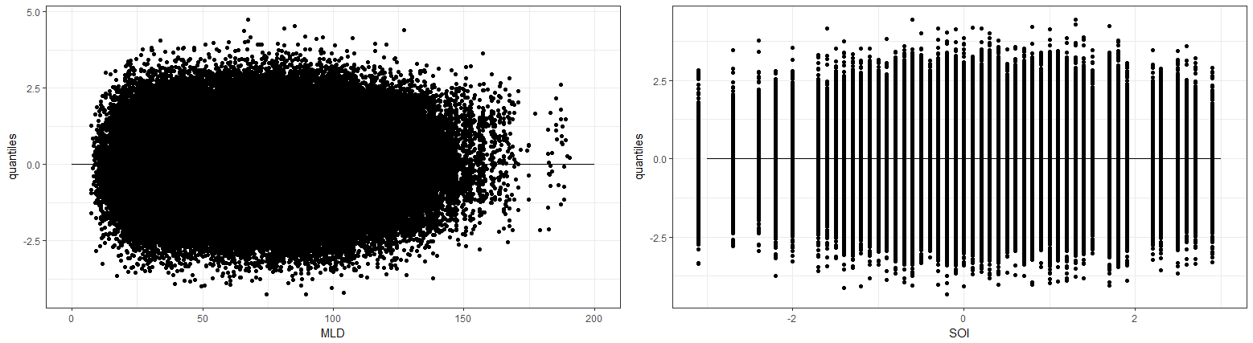

Figure A12. Pearson residuals by mixed layer depth (left) and the Southern Oscillation Index (right). Solid lines indicate 0.

1. PIFSC Working Paper WP-18-??.

   Issued May xx 2018.
2. http://www.esrl.noaa.gov/psd/